The ISO’s Grid Management Charge (“GMC”) is a mechanism for recovering the ISO’s annual revenue requirement from ISO customers. The 2016 charges are as follows:
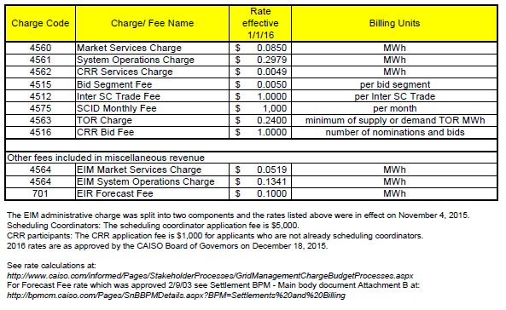
For study purposes we only evaluated the Market Services Charge, System Operations Charge and CRR Service Charge because the additional fees above provide minimal revenue. We estimate that, with regionalization of the ISO, GMC charges will decrease on a $/MWh basis due to improved efficiencies in operating the system and markets along with the increase in load.
Our projection of the GMC in 2020 and 2030 depends on a projection of future revenue requirements, for ISO as currently defined, for ISO plus PacifiCorp, and for an expanded regional ISO. Currently, the ISO can change its annual revenue requirement up to a revenue cap approved by FERC and, as part of the rate design filings with FERC, the ISO requests a cap on its annual revenue requirement. The cap allows the ISO to plan their annual budget without the need to file a tariff rate change with FERC to recover its costs. In 2012, the ISO submitted a FERC filing to revise its Grid Management Charge; FERC approved a cap of $202 million for starting in 2012 with no sunset date on the annual revenue requirement cap. In lieu of the sunset date, the ISO will conduct a cost-of service study every three years. The justification for the $202 million cap is contained within the FERC filing (http://ferc.gov/whats-new/comm-meet/2014/121814/E-14.pdf). Once the ISOs projected annual revenue requirement need exceeds $202 million, then the ISO must seek FERC approval in advance of the financial year for a new cap level. We assume the future revenue requirement is based on this existing revenue requirement cap, and not on the future potential budget.
With the expansion of the ISO balancing authority area to incorporate PacifiCorp, the ISO estimates, for budget purposes, an additional $5 million cost in 2020 to cover direct and indirect expenses. However, the cost is associated with an additional 30 staff. Existing technology and physical infrastructure that the ISO has in place will not change. The additional $5 million in expenses, plus a $5 million for contingencies, would increase the ISO’s annual revenue requirement cap to $212 million.
This estimate is based on the following:
Original Cap $202 million
ISO + PAC $ 5 million
Subtotal $207 million
Contingency (2.5%) $ 5 million
Total $212 million
The ISO estimates the revenue requirement cap would increase an additional $70 million if the ISO expanded to US WECC, without the PMAs, in 2020. The increased cap would be used to cover costs for an estimated additional 160 employees and some physical infrastructure. The infrastructure investments include hardware but not a new building.
This estimate is based on the following:
Cap $212 million
Additional Staffing $ 27 million
Infrastructure $ 36 million
Subtotal $275 million
Contingency (2.5%) $ 7 million
Total $282 million

