California Independent System Operator Corporation

Request for Expressions of Interest
Accessing out-of-state wind resources in Idaho considering the attributes of the proposed Southwest Intertie Project (“SWIP”) – North transmission line

Submittal Deadlines:
Date: September 21, 2022
Time: 11:59 p.m. Pacific Time

Submit Expressions of Interest Response to:

E-mail: regionaltransmission@caiso.com

Introduction

Purpose

Each year, the ISO undertakes a comprehensive assessment of the transmission needs of the system over a 10-year planning horizon and produces an annual transmission plan. In the 2021-2022 planning cycle, the California Public Utilities Commission (“CPUC”) provided a base portfolio and two sensitivity portfolios to the ISO under its approved Power System Plan (“PSP”). The base portfolio and the Sensitivity 1 portfolio included out-of-state wind resources, particularly resources in the New Mexico, Wyoming, and Idaho.

In the ISO’s 2021-2022 Transmission Plan, the ISO explored the implications of out-of-state transmission needed to bring base case amounts and sensitivity amounts identified in the resource portfolios to the ISO boundary, for informational purposes. The ISO conducted these activities in the course of considering and comparing a number of alternative transmission developments including TransWest Express and Cross-Tie, which would access Wyoming resources, and the SWIP-North project, which would access Idaho resources. The latter was also an economic study request submitted into the transmission planning process. The ISO noted its intent to engage further with industry to determine interest in accessing Idaho wind resources through a separate process, and in particular, to respond to the economic study request. The ISO stated that any recommendations resulting from this outreach would be considered as an extension of the 2021-2022 Transmission Plan. As part of this outreach to the industry, the ISO is releasing this request for expressions of interest (“REOI”) to California load serving entities (“LSEs”) to determine their interest and level of commitment in accessing out-of-state wind resources in Idaho.

In developing this Request for Expressions of Interest (REOI), the ISO considered stakeholder feedback and comments regarding the scope and intent of the exercise and the dynamics that led to this point.

The SWIP-North project is the subject of an economic study request. At this point, the SWIP–North transmission project is the sole transmission project under development and known to the ISO that would serve California LSEs in accessing out-of-state wind resources in Idaho. As a result, this REOI will focus on the attributes of the SWIP-North transmission project as the mechanism for accessing wind resources in Idaho. This REOI is not intended to pre-determine any outcome in the ISO’s comprehensive transmission planning process or competitive solicitation process.

Based on the outcomes of this REOI, if there is clear interest and a demonstrable commitment by LSEs to procure Idaho wind resources on a long-term basis, and there are proven benefits to California ratepayers, then the ISO will consider the results of this REOI as an input, in addition to other factors, in evaluating the potential to approve the need for the capacity in the form of the attributes of the SWIP-North project in order to support California’s public policy goals, procurement directives, and reliability needs. In this event, because the SWIP North project was proposed as a regional project for cost recovery via ISO ratepayers, the ISO’s competitive procurement principles and processes would apply.

The SWIP-North transmission project

The SWIP-North transmission project, is a proposed 285-mile, 500kV transmission line from Midpoint in Idaho to Robinson Summit in Nevada, with a transfer capacity of about 2,300 MW. The SWIP-North line will connect to the existing One Nevada (“ON”) transmission line at Robinson Summit. The project also includes phase shifting transformers at Robinson Summit and series compensation on the ON line. The ON line, a 231-mile 500 kV transmission line connects Robinson Summit to the existing DesertLink transmission line which connects Harry Allen to Eldorado. SWIP-North, in conjunction with the ON line and DesertLink will enable California to access Idaho wind resources.

All three phases (SWIP-North, ON, and DesertLink) of what is collectively known as the Southwest Intertie Project, are governed by a Transmission Use and Capacity Exchange Agreement (“TUA”) executed back in 2010 and subsequently approved by the FERC, between Nevada Power Company (“NV Energy”), Sierra Pacific Power Company (“NV Energy”) and Great Basin Transmission LLC, a subsidiary of LS Power. Under the TUA, upon completion of SWIP-North, the full 2,300 MW of transfer capacity will be available and triggers capacity swap such that NV Energy gets 1,200 MW from Midpoint to Harry Allen and LS Power gets 1,100 MW from Midpoint to Harry Allen.

Figure 1: The Proposed SWIP-North transmission project

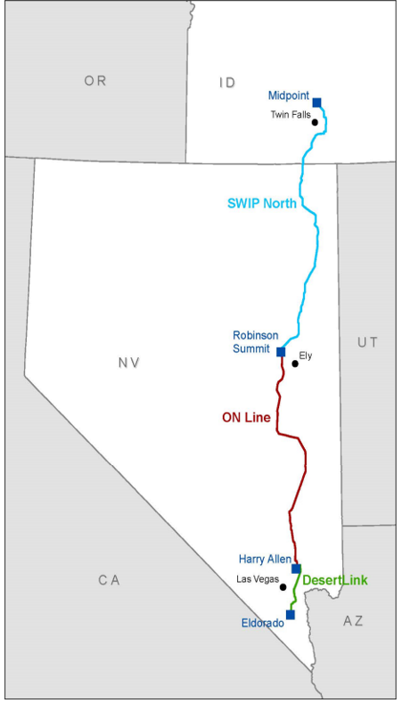

Objectives for releasing this Request for Expressions of Interest

The objectives of this request for expressions of interest are to:

- Ensure alignment with the Commission’s integrated resource planning process, the approved Power System Plan, and the ISO’s Transmission Plan.
- Determine the level of interest and commitment of California load serving entities to meet part of their resource adequacy obligations using out-of-state wind resources from Idaho considering the attributes of the SWIP-North transmission project as the mechanism for accessing wind resources in Idaho.

Important Considerations for LSEs

There are some key aspects for consideration by LSEs related to the attributes of the SWIP-North transmission project. These include:

- As per the TUA, NV Energy will have operational control of SWIP-North, and if the ISO were to move forward with this particular transmission project, it would have access to the offered capacity through entitlements. The ISO will not have operational control of the SWIP-North transmission line.
- Because capacity offered on SWIP-North to the ISO would be through entitlements, generation resources in Idaho would be pseudo-tied to the ISO and would not be part of the ISO footprint or Balancing Authority Area (“BAA”).
- Access to Idaho resources by California LSEs through SWIP-North, will be based on the ISO’s existing maximum import capability (“MIC”) construct, requirements, and allocation process.
- Generation resources in Idaho would need to be connected through the NV Energy interconnection process, or other systems in Idaho, and need firm capacity to get to the northern end of the SWIP-North transmission line.
- Unless information is marked confidential by LSEs, the ISO, at its sole discretion, may share responses to this REOI and supporting documentation provided by the LSEs with the public and appropriate regulatory authorities including, but not limited to, the FERC and the CPUC.

Expressions of Interest Process

Key Features

- Determining interest and level of commitment from LSEs in accessing out-of-state wind resources in Idaho considering the attributes of the SWIP-North transmission project as the mechanism for accessing these resources.
- LSEs to provide total MW amount estimates they are interested in procuring or are in the process of procuring from Idaho, and the expected duration of any procurement.
- LSEs to provide documentation that reflects their level of commitment to procure resources from Idaho such as letters of intent, exclusivity agreements, term sheets, PPAs or PPA proposals from Idaho wind resources, attestation of interest, or information about discussions with Idaho wind resources.
- LSEs to provide, to the extent possible, information regarding the assumptions or considerations on overall integration costs, including transmission costs.

Schedule

- August 25, 2022 – Request for expressions of interest released by the CAISO
- September 21, 2022 – Responses by LSEs to the questions raised in the Response Form attached as Appendix A, due
- October 19, 2022 – Stakeholder call to discuss comments received on the initiative and outcomes from the REOI

Eligibility to Participate

All LSEs in the ISO footprint are eligible to participate in this request for expressions of interest in accessing out-of-state resources.

Key CAISO Personnel

The following are the identities and roles of key ISO individuals undertaking administration of this Request for Expressions of Interest:
- Vice President, Infrastructure and Operations Planning – Neil Millar
- Director, Transmission Infrastructure Planning – Jeff Billinton
- Senior Manager, Transmission Interface Coordination – Biju Gopi

Communications

The mandatory method of communication between interested parties and the ISO during this request for expressions of interest is through e-mail by contacting regionaltransmission@caiso.com

Method of Submission and Deadline

- The Response Form is provided as Attachment A to this Request for Expressions of Interest and expressions must be submitted using this Form.
- Submit expressions of interest by 11:59 p.m. Pacific Time on September 21, 2022 to: regionaltransmission@caiso.com

Review of the Expressions of Interest Form

The ISO will review submitted REOI forms and other information to identify interested stakeholders and may use this information it receives through the REOI forms and other forums to further refine the initiative.

Attachment A
Expressions of Interest Response Form

Please submit this form to the CAISO, to e-mail regionaltransmission@caiso.com, by 11:59 p.m. Pacific Time on September 21, 2022.

Load-Serving Entity (LSE) Name: ____________________________________

Contact Name: ______________________________________

Contact Title: _______________________________________

Phone Number: _____________________________________

Alternative Phone Number (optional): ___________________

E-mail Address: _____________________________________

Questions for Responses:

- Considering the attributes of the SWIP-North transmission project as the mechanism for accessing wind resources in Idaho, are you interested in accessing out-of-state wind resources in Idaho? Please explain in detail your interest or lack of interest:

- If interested, what is your anticipated level(s) of MW you plan to purchase in order to meet your resource adequacy obligations and what is the expected duration of any procurement:

- Are you interested in accessing other resource types (other than wind) in Idaho considering the attributes of the SWIP-North transmission project as the mechanism for accessing these resources? if Yes, please provide type of resource and potential MW(s) and the expected duration of any procurement:

- Can you provide supporting documentation which reflects your intent based on your responses to questions 1 through 3? If Yes, please indicate the type of documentation you plan to provide along with a copy to the ISO, attached in response to this REOI:

- Have you considered overall integration costs, including cost of transmission, in your decision-making or thought process? If yes, please provide the ISO with details on the assumptions or considerations you have made:

- Any other comments that you wish to make, or information you wish to submit to the ISO regarding accessing out-of-state resources in Idaho, which could help the ISO in its decision-making process:

http://www.caiso.com/InitiativeDocuments/ISOBoardApproved-2021-2022TransmissionPlan.pdf
https://energy.nv.gov/uploadedFiles/energynvgov/content/Programs/TaskForces/2017/9b_LS_power.pdf
Note: Financial commitments may be redacted from the documentation provided.
Documentation could be letters of intent, exclusivity agreements, term sheets, PPAs or PPA proposals from out-of-state resources, attestation of interest, or information about discussions with out-of-state wind resources.

