

**Energy Storage Enhancements**

Revised Straw Proposal

March 9, 2022

Market & Infrastructure Policy

**Table of Contents**

1 Introduction 3

1.1 Changes from the Straw Proposal 4

2 Policy Summary 6

3 Stakeholder Process 7

4 Proposal 7

4.1 Energy Storage Resource Model 8

4.1.1 Market Power Mitigation 13

4.2 Reliability Enhancements 16

4.2.1 Ancillary Services 16

4.2.2 Exceptional Dispatch 17

4.2.3 Compensation for Exceptional Dispatch to Hold State of Charge 19

4.2.4 Tools for Local Areas 21

4.3 Co-located Enhancements 23

4.3.1 Enhanced Co-Located Functionality 25

4.3.2 Pseudo-Tie Resources Functionality 27

5 WEIM Classification 28

6 Next Steps 28

# Introduction

Storage developers are rapidly deploying new utility-scale resources onto the California grid to provide replacement capacity for retiring resources and to meet procurement mandates imposed by the California Public Utilities Commission. These storage resources will help the state meet clean energy and climate goals. Ultimately, storage resources will be available to meet energy needs during most periods when renewable resources are not available to generate. Today, there is just over 2,600 MW of installed storage capacity in the ISO market. The ISO observes these resources primarily charging during the lowest priced periods of the day (when solar is abundant) and discharging during the highest priced periods of the day. Today the ISO relies on storage resources for the critical operation of one local capacity area. The ISO anticipates that storage resources will also be necessary for the reliable operations in many other local capacity areas in the future. In the ISO’s annual local capacity technical report, the ISO is proactively estimating the amount of energy storage that can be added to each local capacity area based on charging restrictions due to anticipated load, other local generation capability required to meet mandatory standards and transmission capability under applicable contingency conditions.[1]

The ISO market models are evolving to address storage requirements. The fourth phase of the energy storage and distributed energy resources (ESDER) initiative, which was recently implemented, included development of market power mitigation for storage resources and tools to help scheduling coordinators manage state of charge. Measures targeting storage in the resource adequacy enhancements (RAE) initiative include counting rules and bidding obligations for storage resources and the introduction of real-time end of hour market constraints to ensure day-ahead discharge schedules are feasible in the real-time market.[2]

In comments to this initiative, prior initiatives, and through other avenues, storage developers and operators expressed concern with existing market rules, optimization algorithms, and settlement processes applied to the energy storage resources. A principle concern raised by the storage community is a lack of compensation during critical periods when the ISO must retain state of charge on storage devices, which may preclude participation in the real-time markets. Existing bid cost recovery rules are designed based on traditional generation resources and do not consider energy storage charging and discharging cycles. A primary objective of this initiative is to develop a set of solutions to enhance the optimization of storage resources and to allow additional flexibility for storage operators to manage state of charge in the real-time markets. The ISO proposes a new model, called the energy storage resource (ESR) model, which is unique from existing models because bids are predicated on state of charge values, rather than a dispatch instruction for power. This proposal is outlined in section 4.1.

In response to the summer 2020 outages, a number of new market features were implemented prior to summer 2021 to help the ISO manage the grid under stressed conditions. One of these measures included a new feature called the minimum state of charge requirement, which is imposed on storage resources providing resource adequacy on days when the day-ahead market has insufficient supply to match demand. These measures help ensure sufficient state of charge across the storage fleet during conditions when supply is tight. These measures were approved by FERC as temporary measures in place for a two year period, while the ISO develops new policy to manage storage resource state of charge during critical periods. These measures were implemented to ensure reliable operation of the large influx of new storage resources coming onto the system. In this proposal, the ISO proposes new mechanisms and improvements to existing mechanisms meant as permanent market features. These proposals are outlined in section 4.2.

Finally, the ISO acknowledges concerns regarding investment tax credits and property taxes and proposes changes to the existing co-located model that can be used by these resources for a limited period of time. These changes will completely prevent co-located resources from charging when beyond generation levels for on-site resources. These proposed changes are outlined in Section 4.3.

## Changes from the Straw Proposal

This revised straw proposal includes several significant changes, and details not included in the straw proposal. Most of these changes are in direct response to stakeholder comments.

Several stakeholders asked for more details about how bidding for the energy storage resource model would work. A numerical example and graphical representation is added in section 1.1 to describe how bidding under the energy storage resource model will work. Details about operating along different segments of the curve and emerging prices are also included in the description.

Stakeholders also asked how market power mitigation would be applied to energy storage resources. A new section of the paper, section 4.1.1, is added to describe how market power mitigation will be applied to energy storage resources. The overall premise is not dissimilar from existing market power mitigation rules for storage resources using the non-generator resource model, but includes a new sloped concept to the discharging portion of the default energy bid curve.

Stakeholders requested specific details on how opportunity costs would be determined for storage resources that are exceptionally dispatched to hold state of charge. Details on compensation for these exceptional dispatches are added to section 4.2.3. A simplified numerical example of how this calculation may work in practice is included in this section of the document.

Several new details are included describing special accommodations that will be made for storage resources using the co-located model that are requesting special treatment because of contracts that include allowances for investment tax credits of property taxes. The ISO notes that these accommodations will be allowed for resources that are already on the system at the time this policy is implemented, but will not make accommodations for resources coming onto the system after this policy is implemented. Further, the ISO is willing to make these accommodations for up to a 5-year period, but is not willing to extend these accommodations beyond that time frame. One key change from the previous policy is that the ISO proposes a limitation for these resources to avoid being dispatched above generation from on-site renewables, except during situations where there is a grid emergency or an emergency is imminent.

Stakeholders requested several other changes, clarifications, and additional details in the issue paper, many of which have been included in this paper.

Finally, the ISO has not formally included a proposal to account for changes in state of charge from regulation or other ancillary service awards. The ISO is still considering such policy and may include this in future iterations of this proposal.

# Policy Summary

As a quick reference and summary, this policy includes the following proposals:

* (4.1) New ESR model to allow storage to submit bids in incremental SOC
  + Storage may elect to use either the ESR or NGR model
  + ESRs must submit a bid curve for charging and for discharging
    - In aggregate both bid curves can include up to 10 segments
  + Pmin/Pmax can decrease at low/high state of charge levels
  + Transition times between charging and discharging will be modeled
* (4.1.1) ESR resources will be subject to market power mitigation
  + Default energy bids will be calculated similar to NGR resources
  + Real-time default energy bids will include a sloped component
* (4.2.1) AS awards for storage will require corresponding energy bids
* (4.2.2) Storage resources may be issued EDs to hold state of charge
  + Storage may receive a traditional ED or an SOC ED, but not both
* (4.2.3) Compensation will include lost opportunity from not generating
  + ISO will calculate counterfactual energy revenues with and without the exceptional dispatch in place
  + LMPs actually realized will not be generated
  + Time horizon will include ED period plus duration of storage
* (4.2.4) The ISO may procure state of charge for day-ahead contingencies
  + These procurements will be priced in the market
* (4.3.1) Implement electable co-located model
  + Available to storage with contractual obligations to not ‘grid charge’
  + Available to resources participating prior to implementation of policy
  + Available only to resources participating for less than 5 years
  + Storage is never dispatched above co-located renewable schedules
  + Storage may deviate down to match solar, when less than forecast
  + Deviations will be subject to imbalance energy charges
  + Storage submits outages when depleted and no ability to charge
* (4.3.2) Allow for co-located pseudo-tie resources to apply ACC
  + Resources under an ACC must be pseudo-tied from the same BAA

# Stakeholder Process

The ISO is at the “straw proposal” stage in the energy storage enhancement (ESE) stakeholder process. Figure 1 below shows the status of the overall energy storage enhancements stakeholder process.

The purpose of the straw proposal is to include detailed solutions for resolving issues related to the integration, modeling, and participation of energy storage in the ISO market. The ISO will publish a number of straw proposals, and solicit stakeholder feedback after each iteration. The ISO will publish a draft final proposal, solicit stakeholder feedback and then conclude with a final proposal. As appropriate, the ISO may organize focused working groups to address complex issues or issues that have cross-jurisdictional concerns as we move through the initiative process.

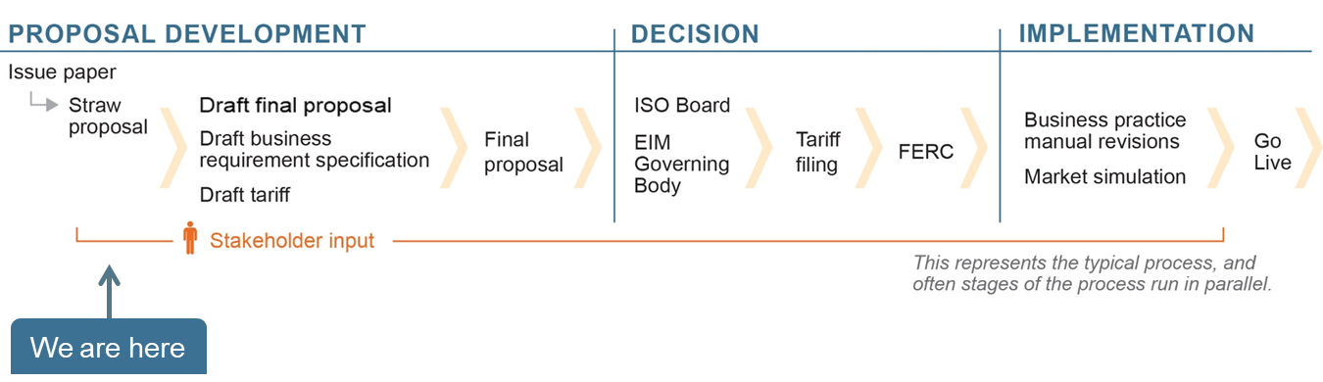

Figure 1: Stakeholder Process for ESE Stakeholder Initiative

# Proposal

The ISO introduced the non-generator resource (NGR) model in 2012 to allow for wholesale market participation of energy storage resources. Although the ISO believes the non-generator resource model effectively integrates energy storage resources today, the increasing number of storage devices participating in the wholesale market warrants consideration of further market model enhancements to ensure storage resources are appropriately compensated and the market can accommodate the unique features of storage resources. Stakeholders identified a number of potential enhancements for the ISO to consider to help better model storage resources. While the ISO’s day-ahead market optimizes all resources over a 24-hour period, the real-time market has a shorter optimization horizon, which can make it more difficult to capture periods when it is critical that the storage resources have state of charge for several hours to meet system needs. The goal of this initiative is to explore enhancements that could help storage scheduling coordinators better manage resource state of charge and continue to ensure efficient market outcomes.

## Energy Storage Resource Model

During this stakeholder process and previous stakeholder processes, storage resource operators have requested additional capability to manage state of charge and potentially have bids that change based on the state of charge. In response to this feedback, the ISO proposes a new model, called the energy storage resource (ESR) model. Storage resources may elect to use this model instead of the existing non-generator resource (NGR) model. The energy storage resource model will require scheduling coordinators to submit bids in terms of incremental state of charge instead of traditional bids submitted in terms of incremental energy. This model will allow storage resources to reflect that incremental costs to charge and discharge are different at different levels of state of charge. Specifically, the energy storage resource model will allow storage resources to offer lower prices to provide energy when a battery has a nearly full state of charge and higher prices when it is nearly depleted. This new model would be employed in the ISO’s market software for both the day-ahead and real-time markets and could be used by participants in the western energy imbalance market.

The energy storage resource model would include two incremental SOC bids, one for charging and one for discharging, with up to a total of 10 segments. Each bid curve will span a state of charge range from a minimum state of charge to a maximum state of charge. An energy storage resource will be scheduled to charge, discharge, or remain at the same state of charge according to the cost reflected by its charging and discharging bid curves.

Figure 2 illustrates how bids could look for the energy storage resource model. The horizontal blue lines represent the bid segments to charge the storage resource, while the horizontal red lines represent the segments to discharge.

Figure 2 Energy Storage Resource Bid Curves

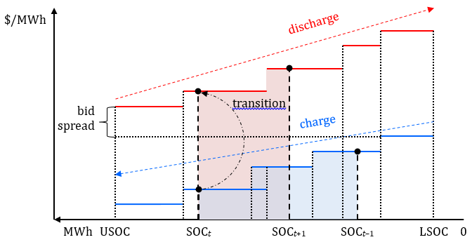

At any given time, *t*, the market software will issue an instruction for the resource to hold state of charge, to charge, or to discharge. The software will consider the cost to charge or discharge at the current state of charge, ${SOC}_{t}$, on the charging (blue) and discharging (red) bid curves. For charging, the SOC increases, whereas for discharging the SOC decreases between consecutive intervals. The example in Figure 2 shows a dispatch instruction to charge between intervals *t–1* and *t*, where the storage resource receives a negative energy schedule to increase state of charge from ${SOC}_{t-1}$ to ${SOC}_{t}$. During the following interval the resource receives a positive energy schedule to discharge, which implies a decrease in state of charge from ${SOC}_{t}$ to ${ SOC}_{t+1}$.

The market software will charge the resource when the charging benefit, shown as the blue-shaded area under the charging bid, is higher than the cost of the required energy from other resources. Essentially, when prevailing market prices are below the bid to charge the storage resource will receive a schedule to charge. The market will discharge the resource when the discharging cost, shown as the red-shaded area under the discharging bid, is lower than cost of the displaced energy from other resources. Essentially, when prevailing market prices are above bids to discharge the storage resource will receive a schedule to discharge. Note that as the state of charge increases, the benefit to charging the resource decreases because of the downward sloping bid curve. Similarly, as the state of charge decreases, the cost to discharge the resource increases.

Scheduling coordinators could use the energy storage resource model to specify that discharging the resource to very low state of charge levels becomes more costly or charging the resource to very high state of charge levels becomes less beneficial.

The ISO is not proposing changes to the timing of bid submissions or scheduling for energy storage resources. Similar to other resource models, the energy storage resource model would require bids submitted for each operating hour of the day. These bids would be due at 10:00 am prior to the day-ahead market run and 75 minutes prior to the start of each trading hour in the real-time market.

The ISO notes that developing the energy storage resource model may obviate the need for some enhancements to the non-generator resource model. However, this would assume migration from the current non-generator resource model to the energy storage resource model. The ISO welcomes comments on whether the energy storage resource model is attractive to storage resources, and why they may prefer to use one model over the other.

The storage community noted several improvements that could help better model storage resources during this and previous stakeholder processes. Some of these improvements include the ability to offer a specific ‘bid spread’ and the ability to show reduced charging capability when a storage resource is near full state of charge. Additionally, long duration storage technologies may require transition times to switch from charging to discharging. The ISO believes these enhancements are addressed with the energy storage model.

**Bid Spreads**

The energy storage model will require storage resources to bid two independent bid curves that cover the same operating (state of charge) range. One of these bid curves is specific to charging and the other is specific to discharging. The gap between these two bid curves could be used to represent a ‘spread,’ or the difference between a price the resource would be willing to charge at and the price the resource would be willing to discharge at. The concept of two bid curves for the same operating range is unique to the energy storage resource model.

**Variable Charging and Discharging Rates**

Battery storage developers and storage operators note that charging and discharging rates can degrade as resources reach very high or very low states of charge. This can lead to a resource being unable to meet schedules if the modeled rate that it can charge (Pmin) or discharge (Pmax) is constant across the entire range of state of charge for the resource. Stakeholders indicate that some storage resources can charge at a very high rate when state of charge is below a given value, but beyond that the resource can only charge at a diminishing rate. Similarly, some storage resources can discharge at a very high rate when state of charge is above a given value, but beyond that the resource can only discharge at a diminishing rate.

**Transition Times**

The ISO received comments from stakeholders asking the ISO to consider additional features in a model for storage resources to accommodate new storage technologies that are expected to come onto the system in the future. One feature that may be more common in new storage technologies is the inability to seamlessly switch from charging to discharging. Today, the ISO models storage resources as continuous resources with the ability to switch between charging and discharging from one dispatch instruction to the next, which is common for lithium-ion batteries. The proposed energy storage resource model will include the ability to enforce a minimum transition period, in minutes, between charging and discharging.

**Example Bids**

Based on feedback from the straw proposal, stakeholders requested specific examples of how bidding might work for a storage resource using the energy storage resource model.

Suppose a +/-25 MW storage resource has 100 MWh of energy storage capability, from 0 MWh to 100 MWh. The resource bids to charge, regardless of state of charge, anytime prices are less than $20/MWh. The resource is also willing to discharge at $45/MWh when state of charge is above 80 MWh, at $60/MWh when state of charge is between 15 MWh and 80 MWh, and at $100/MWh when state of charge is below 15 MWh. The bid curve for this resource is depicted in Figure 3Figure 3 Example Bid curve for a Storage Resource.

Figure 3 Example Bid curve for a Storage Resource

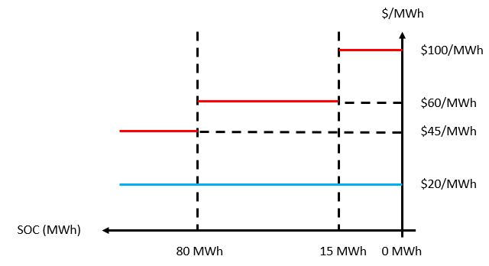

In this example, if the energy storage resource is at 50 MWh state of charge and prices are above $60/MWh, the resource will be dispatched to discharge at Pmax (25 MW). If prices are below $20/MWh the resource will be dispatched to charge at Pmin (-25 MW). If the resource is marginal, it may set the price at $60/MWh and may receive a dispatch instruction anywhere in the discharge range, between 0 MW and +25 MW. Similarly, is may set price at $20/MWh and receive dispatch instructions to charge anywhere between -25 MW and 0 MW.

The results are similar for intervals when the storage resource has a very low state of charge or a very high state of charge. For example, if the storage resource has a state of charge of 10 MWh, prices will need to materialize at or above $100/MWh in order for the resource to receive a dispatch instruction to discharge. Similarly, if the resource has a state of charge of 90 MWh, energy prices will need to be at or above $45/MWh for the energy storage resource to receive a discharge instruction.

Sometimes the storage resource will transition between two bid curves when being dispatched by the ISO. For example, this resource could have a state of charge of 16.5 MWh and receive an RTD dispatch instruction to discharge at 24 MW. This will result in a discharge of 2.0 MWh of energy and result in the resource being dispatched partially in the $60/MWh discharge bid range and partially in the $100/MWh discharge bid range. In this case, the marginal price for this dispatch instruction would need to be $70/MWh ({1.5 MWh * $60/MWh + 0.5 MWh * $100/MWh} / 2 MWh) to satisfy the underlying bid curves.

### Market Power Mitigation

The ISO will subject resources using the energy storage resource model to market power mitigation, and they will have access to a new default energy bid. In phase 4 of the energy storage and distributed energy resource stakeholder initiative, the ISO developed a framework for estimating marginal costs for storage resources.[3] A default energy bid was established through this effort that represents these costs. The default energy bid included estimates of marginal cost to operate the resource, estimates of cost to purchase energy, and for real-time markets, opportunity costs to prevent discharge prior to the peak net-load hours of the day. The ISO proposes an expansion on these ideas to construct a default energy bid for storage resources using the energy storage resource model.

The ISO proposes a default energy bid for resources using the energy storage resource model that includes many of the same features, but also provides additional functionality. The ISO is not planning to make changes to the default energy bid for resources using the non-generator resource model as a part of this imitative. The ISO proposes a default energy bid for energy storage resources that includes the following:

1. Cost for storage resources to buy energy
2. Cycling costs
3. Opportunity costs to charge resources and additional opportunity of depleting state of charge
4. **Estimated costs to charge**

These are estimated the same way that costs are estimated for resources using the non-generator storage model. In the day-ahead market, these costs are estimated from the mitigation run of the market to estimate prices. To perform this estimation the ISO assumes that storage is fully charging – from 0 MWh or the minimum state of charge to full state of charge – during the lowest priced contiguous block of hourly prices during the day.[4] For example, a typical 4-hour duration resource takes just over 4 hours to charge, considering round-trip efficiencies. The ISO would use the associated prices from these hours to determine an estimate for charging costs for the resource. These estimates for prices may be conservative as storage resources may not be scheduled to completely charge in day-ahead market, but instead may actually receive schedules to charge in the real-time market when prices are even lower than expected prices in the day-ahead market. Additionally, these prices may actually materialize at lower levels in the integrated forward market run of the day-ahead market than what was anticipated in the mitigation run.

In the real-time market the ISO will plan to use a similar process to determine estimated costs for charging storage using finalized values established from the day-ahead market from the integrated forward market run. These costs will feed into the default energy bid for resources using the energy storage resource model.

1. **Cycling Costs**

Cycling costs for non-generator storage resources are submitted to the ISO by scheduling coordinators and are subject to verification. The ISO proposes the same process for cycling costs for storage resources using the energy storage resource model. The ISO understands that storage resources can have higher costs for cycling beyond the normal operating designs. The ISO anticipates developing a conservative approach to estimating the value for cycling costs and will continue to use the upper bound for cycling costs in calculating the default energy bid for resources using the energy storage resource model. This is similar to the current approach for the non-generator resource model.

1. **Sloped default energy bids**

The primary purpose of the energy storage resource model is to provide transparency for the increasing value of energy as state of charge decreases. Similarly, the ISO intends to ensure that the default energy bid for the discharge portion of the bid curve in the real-time market for this model also increases as state of charge decreases.

The ISO proposes to use prices from the integrated forward market run of the day-ahead market to determine this slope. Specifically, the slope will be determined between the difference between the highest priced hour of the day and the *nth* highest priced hour of the day, where *n* corresponds to the duration of the storage resource. For example, the slope of a default energy bid for a four hour duration resource would use the difference between the highest priced hour of the day and the fourth highest priced hour of the day to determine slope. Mathematically, this can be represented as:

$${DEB}_{sl}=\frac{{En}_{1}-{En}_{n}}{n}$$

Today the ISO does not offer a concept of sloped bids curves, but instead uses segments with constant prices (slope equal to 0). This same concept will apply to default energy bids for the energy storage resource model, with the quantity (MWh) segments of the bid curves specified by the bids from the resource. The value ($/MWh) of the default energy bid curve will be derived from that the slope specified in the equation above.

Figure 4 Sloped DEB calculation

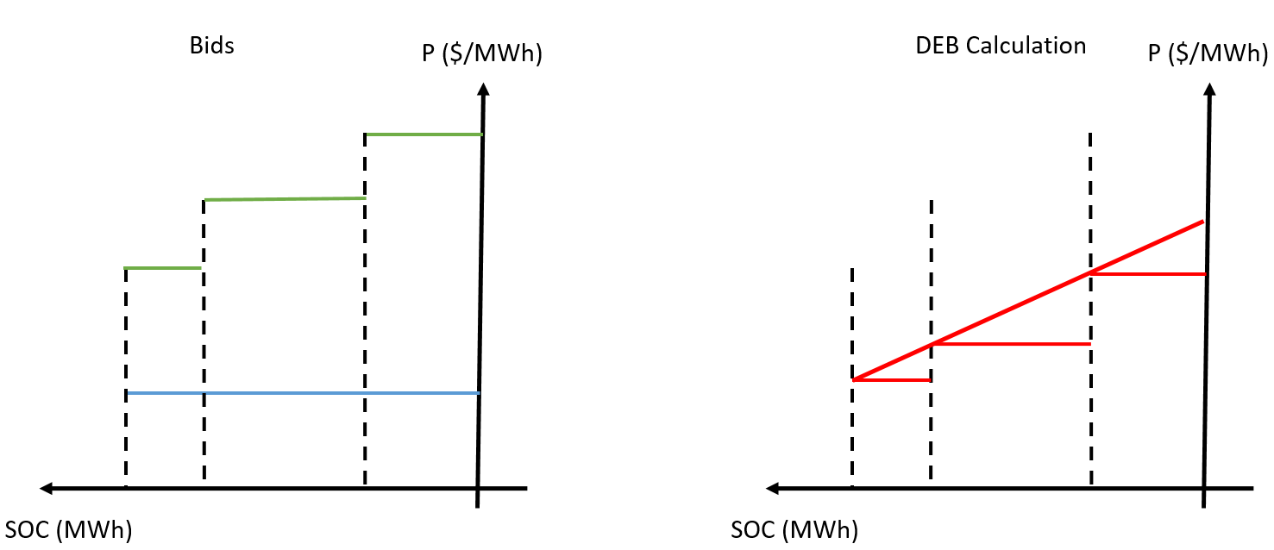

The process to determine this sloped bid is illustrated in Figure 4 and Figure 5. The ISO will use the following process to determine the default energy bids for storage resources. First, the ISO will estimate the cost for the storage resource to buy energy and add the cycling costs to that value, then this value will be compared to the opportunity cost. The greater value will set the leftmost point of the sloped red curve in Figure 4 and Figure 5. The slope will then be determined by the above formula and that will be applied from the leftmost point. The default energy bid segments will then be determined the intersection of the start of the bid segment (left limit of bid) and the diagonal red line.

In this particular example, the scheduling coordinator bid three discharging segments into the market for the resource, which resulted in three segments of the default energy bid, represented in Figure 5 by the three horizontal bid red lines. Then if market power mitigation is applied the default energy bid will be used in lieu of any bid curves that are higher.

Figure 5 Sloped DEB application

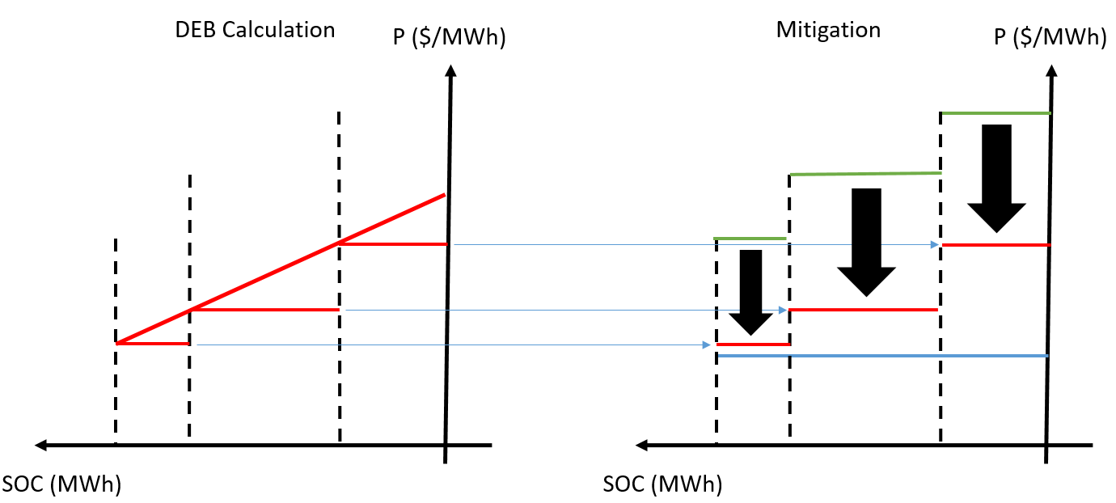

## Reliability Enhancements

### Ancillary Services

Today the ISO requires all supply resources that provide ancillary services to have sufficient energy if called upon by the market. Specifically, the ISO requires that resources be capable of providing energy continuously for 30 minutes for regulation, spin and non-spin awards. This means that a storage resource with a 10 MW award for upward regulation up, must have at least 5 MWh of state of charge going into that period.

A number of issues have been identified around the ability of storage resources to provide ancillary services to the market and the feasibility of awards from the day-ahead market into the real-time market. Today, the real-time market requires a state of charge sufficient so that storage is capable of delivering at least 30 minutes of sustained energy delivery for each ancillary service award. If a storage resource has insufficient state of charge, a portion or all of the award may be rescinded in the real-time market. If an award is rescinded for any resource, the 15-minute market may procure additional ancillary service capacity. Unfortunately, the 15-minute market runs 38 minutes prior to the start of an operating interval and a storage resource may have a depleted state of charge at the actual time it is providing the ancillary services.

Day-ahead ancillary service awards over multiple consecutive hours may not be feasible in the real-time market because the state of charge could be potentially depleted by use of the resource providing these services. The ISO observed cases when storage resources were completely committed for ancillary services for multiple hours, leaving no ability to charge or discharge the resources. If the state of charge of these resources is depleted while providing these services, they may not be available to meet their day-ahead ancillary service schedules in the real-time market. This could lead the ISO to be significantly short of ancillary services in the real-time operating horizon. This could also be challenging for scheduling coordinators that were counting on revenue from ancillary service awards in the day-ahead market, but instead have those awards rescinded in real-time and subject to no pay.

To prevent these concerns, the ISO proposes that in the future all ancillary service awards for storage resources be accompanied with bids for energy. For example, a storage resource with a 10 MW regulation up award, could be required to provide a bid to charge for 10 MW.[5] Similarly, regulation down awards will require accompanying energy discharge bids. Imposing a requirement like this will ensure that the ISO energy market can charge or discharge a resource while it is providing regulation services at the same time, and prevents situations where a storage resource is fully encumbered and cannot be charged or discharged by the market.

These requirements will help ISO markets charge or discharge a storage resource as needed, ensuring sufficient state of charge to support ancillary service awards in the real-time market.

### Exceptional Dispatch

ISO operators can exceptionally dispatch resources on the grid to ensure reliability. This includes dispatch instructions to provide energy to the grid and dispatch instructions for storage resources to charge from the grid. If a resource is dispatched for energy delivery to the grid, then the resource will receive compensation at the higher of their bid or the prevailing price for the dispatched (MW) amount.

The ISO proposes new functionality that will allow the ISO operators to dispatch storage resources to hold a certain state of charge (MWh), in addition to the traditional (MW) exceptional dispatch.[6] The ISO operators will have a tool that allows for dispatch of storage resources to charge to and hold a specific level of state of charge for a specific duration of time. For example, a specific exceptional dispatch may require a storage resource to charge to 500 MWh and hold that state of charge through the end of hour ending 17. When that energy may be needed later in the day, operators may subsequently issue a dispatch for the resource to provide energy through a typical exceptional dispatch, or simply release the resource from the exceptional dispatch with a state of charge target. The ISO always seeks to avoid exceptional dispatch, and would hope to never need this tool. Nevertheless, the proliferation of storage has come when the ISO also is capacity constrained in peak hours. The ISO thus believes it is prudent to develop such a tool. The ISO notes this tool is consistent with the ISO’s abilities to issue exceptional dispatches today, but has included a discussion here for transparency, and to discuss potential unique settlement issues.

Compensation for traditional exceptional dispatch is based on the ‘bid or better’ paradigm where resources receive compensation for energy delivered in response to exceptional dispatch instructions at the higher of bid prices or prevailing market prices. This ensures that resources receive compensation at least at marginal costs to provide energy. Today, if the ISO operators want a resource to hold state of charge, they would issue an exceptional dispatch at or near 0 MW, and would result in almost no compensation for the exceptional dispatch. At the same time the storage would miss opportunities to participate in the real-time market during these periods and potentially earn significantly high market revenues than they would otherwise earn.

Resources below target state of charge levels, when exceptionally dispatched to a certain state of charge, will be required to charge up to the target levels. These exceptional dispatch instructions will be issued from the ISO similar to traditional exceptional dispatch instructions today. For example, if a storage resource is exceptionally dispatched to be at 100 MWh of state of charge, but is currently only at 70 MWh, the resource will receive traditional exceptional dispatch instructions to charge while moving from 70 MWh to 100 MWh. Once at 100 MWh the resource will receive exceptional dispatch instructions to hold state of charge.

### Compensation for Exceptional Dispatch to Hold State of Charge

Storage resources receiving exceptional dispatch instructions to hold state of charge will be compensated using a different methodology than traditional exceptional dispatch. This compensation will be based on an opportunity cost methodology and will capture the revenues that the resource would have received had it been optimally participating in the market, during the exceptional dispatch and for a period of time after the exceptional dispatch.

The ISO received a number of stakeholder comments that included feedback on prices that would be used while performing the analysis for this compensation. Stakeholders noted that actual prices may have been drastically different if storage resources were participating were not effectively barred from market participation because of an exceptional dispatch, and instead were allowed to provide energy in the market. While, the ISO agrees that these counterfactual prices may better used in this calculation, however, actually deriving these values may be complicated. While rerunning one market interval is possible, rerunning potentially hours of market results, is not technologically feasible. The ISO is not able to feed output results of one market run into a second market run and continue to cascade these values as time moves forward. Tracking and maintaining state of charge could be incredibly important, when developing a solution for storage resources.

**Compensation Calculation**

For each exceptional dispatch issued to a storage resource to hold state of charge, the ISO will compute two counterfactual values. The first will be the revenue maximizing energy dispatch the resource would have received if there was no exceptional dispatch in place, and the second is the revenue maximizing energy dispatch that the resource would have received if the exceptional dispatch was still in place.

As noted above, the ISO recognizes that storage resources that are issued exceptional dispatch instructions to hold state of charge can impact prices, particularly in local areas where there is little other generation that can serve load. However, the ISO is unable to update these values and will use realized locational prices to complete this analysis.

The time horizon for these counterfactuals will start from the first interval where the exceptional dispatch to hold state of charge is in place. The time horizon will include the entire horizon of the exceptional dispatch and will include an additional period of time equal to the duration of the storage resource at the conclusion of the exceptional dispatch. For example, if the exceptional dispatch is 1.5 hour in duration and the storage resource is a 4 hour duration battery, then both counterfactuals would include 5.5 hours and would start at the first interval when the exceptional dispatch was put in place.

After calculation of both counterfactual values, the ISO will compare them. If the resource would have been able to make additional revenue if the exceptional dispatch was not in place, then the resource would be awarded the difference between the counterfactual revenue earned without the exceptional dispatch in place and with the exceptional dispatch in place, as an additional uplift payment for the day.

**Example**

This highly simplified example illustrates how this calculation could be completed. It uses the same hypothetical resource discussed above with a -25 MW lower operating limit, +25 MW upper operating limit, 0 MWh minimum state of charge, and a 100 MWh maximum state of charge. Further, for simplicity, we assume that the resource does not have any cycling costs associated with operating. These values will be included in the revenue calculations, when provided.

For simplicity, this example does not include 5-minute prices, but instead includes prices during half hour blocks. These are meant to reference segments of 6 5-minute prices. For this example, we assume that each of the 5-minute prices within the illustrated interval results in an identical price, specified in the excel sheet.



The first column of this sheet represents the hours where the specific interval, in half hour increments. The second column represents actual realized locational marginal prices. Columns 4-7 and columns 9-12 represent the counterfactual ideal dispatch instructions, to profit maximize if there was no exceptional dispatch and the ideal dispatch instructions with the exceptional dispatch in place, respectively. Specifically, these sets of columns include information on current state of charge, dispatch instruction, state of charge resulting from the dispatch instruction and the total revenue realized from the dispatch instruction.

First, note that the time frame included in this example includes 5.5 hours of data. This corresponds to the initial exceptional dispatch, during intervals .5, 1, and 1.5, followed by 4 additional hours of data, corresponding to the duration of the storage resource. Second, prices during hour 1 and 1.5 actually materialized at $300/MWh. Third, for this analysis the ISO will not generate counterfactual prices for intervals after the exceptional dispatch is in place.

Columns 5-8 represent the revenue maximizing, or ideal, dispatch for the resource had there been no exceptional dispatch, with corresponding state of charge values and revenues. In this scenario, the resource would have discharged energy during the high priced periods when the exceptional dispatch was in place (hours .5 through 1.5), then recharged for one half hour (hour 2), then discharged for most of the remainder of the period, excluding hour 4.5 when prices were low. This would have resulted in a hypothetical revenue of $14,473.

Columns 10-13 represent the revenue maximizing, or ideal, dispatch for the resource while observing the exceptional dispatch. In this scenario, the resource would have been limited by how much energy could have been discharged between hours .5 through 1.5. This allows for a relatively full state of charge at the conclusion of the exceptional dispatch, and results in discharging the resource anytime prices are above $50/MWh later in the day. Operating following this pattern would have resulted in a hypothetical revenue of $9,400.

In this instance the resource would be made an additional payment of $5,073 ($14,473 - $9,400) as an opportunity cost payment for incurring this specific exceptional dispatch instruction.

### Tools for Local Areas

Local areas can require additional effort to ensure reliable operation. Today, the ISO uses tools to ensure that there is sufficient resources commitment in local areas during periods when conditions are particularly tight. In the future, as storage becomes more prevalent, the ISO will rely on storage resources even more to ensure reliable local operation. To do this the ISO may need to ensure state of charge availability from storage resources in local areas. The ISO proposes the ability to automatically secure state of charge for local needs in addition to system needs through the day-ahead market process.

Today, the ISO takes a number of steps to ensure local reliability prior to running the day-ahead market. Not only does the ISO ensure that the model of the grid matches real conditions as closely as possible, but also that reliability can be maintained in local areas even with the loss of the certain critical elements. For example, the loss of the most critical electrical element, or an N-1 condition, could be included in the day-ahead market run. These conditions imposed in the market ensure voltage stability and prevent thermal overloads should the grid actually lose these critical elements. When the day-ahead model solution is generated, it includes these conditions and includes prices generated with congestion from including these contingencies.

Further, the ISO also has the ability to impose second tier constraints, known as minimum on-line commitment constraints, in the market to ensure against further losses, which do not impact prices or congestion. For example, these could include the loss of the second most critical element, or an N-1-1 condition, in a local area. These additional constraints can result only in commitment of resources, and will not result in energy schedules. Once committed these resources are required to be available in the real-time market, and will serve as a safeguard against key element losses in the local area.

Constraints that are priced in the market do result in energy schedules, and ensure that the market would operate reliably even in the absence of the key electric element, which is usually in service in the actual real-time market. Today, this might imply a start-up instruction and energy schedule for a gas resource in a local area, even though that gas resource may not be strictly needed – if the electric element is on-line in the market. Similar to gas resources, storage resources may also be used to meet these constraints. They may be scheduled earlier in the day to charge, and provide energy later in the day to meet local demands that no or few other resources can satisfy when the outage is modeled.

Second tier constraints do not result in additional energy schedules, but may result in resource commitment. Essentially, these constraints ensure there is enough capacity in the local area to manage the contingency, but are not necessarily scheduling energy to meet it. For natural gas fired resources that are effective at managing the second tier outage, this could imply dispatch instructions to start units, which will also ensure availability in the real-time market. The market treats storage resources differently. They are always on-line, and therefore automatically qualify to meet second tier ‘capacity’ requirements. However, even though the storage resources may be on-line they may not have sufficient state of charge to provide energy to maintain reliability, should an outage occur.

The ISO proposes to enhance the logic for second tier constraints to ensure that capacity is available from traditional resources and that energy is available from storage resources to maintain reliability in the event a key grid element is lost to meet local reliability needs. These requirements will be imposed as constraints in the day-ahead market, and any results will include an efficient procurement of resources that is factored into market prices.

## Co-located Enhancements

Many stakeholders commented that current investment tax credit (ITC) rules impact the financial incentives for storage resources. The investment tax credit rules also can impact contracting for storage resources. Some contracts expressly prohibit ‘grid charging’ for storage resources because grid charging can reduce the revenue stream for a storage or co-located project. At the July 26 ISO workshop stakeholders suggested that the ISO introduce a mechanism to ensure revenue recovery if a storage resource seeking the investment tax credit were to incur costs due to grid charging. Such a mechanism may reduce qualifications in future contracts that prohibit grid charging and may allow storage resources seeking to bid charging capacity into the market to do so more freely.

In response to these requests, the ISO proposes enhancements to ensure co-located storage resources with investment tax credit or property tax limitations to better reflect their availability in the ISO markets. Further, this should incentivize owners to bid more charging capability into the market, as charging would always be compensated, including incidental costs from grid charging.

**Investment Tax Credit Mechanics**

The ISO understands that the US Internal Revenue Service oversees a program for investment tax credit for renewable facilities with storage resources. This investment tax credit is set up as a mechanism to incentivize renewable generation and pair that generation with storage projects for more robust usage. Specifically, the investment tax credit allows for the recovery of up to about one third of the annualized costs of a storage resource in the form of a tax credit for renewable facilities. This credit is reduced by the fraction of energy that the resource uses to charge from non-renewable resources compared to the total amount of energy that the resource uses to charge from all sources. The storage resource is not eligible for any investment tax credit if this fraction exceeds 25%.

The tax credit phases out over a five year period, where resources receive up to 100% of the credit during the first year, 80% during the second year, 60% the third year, etc., phasing out completely by the sixth year.

For example, a storage resource with $30 million annualized costs would be eligible for up to a $10 million investment tax credit in the first year, an $8 million dollar tax credit the second year, et cetera. If, in the second year of operation, this resource charged 95 GWh from renewable energy and charged 100 GWh overall, they would be eligible for $7.6 million ($8M * 95 GWh / 100 GWh) for this investment tax credit. Figure 6 illustrates this example.

Figure 6: Annual Investment Tax Credit (ITC) Example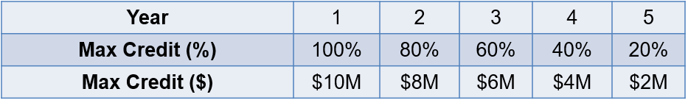

If an estimate of total charging can be made for a storage resource, then a value can be assigned on any specific amount of charging where the amount of energy charged by the storage resource is greater than the amount of generation from the renewable resource.

**Property Tax Mechanics**

The ISO also has been informed about property tax concerns for storage projects. Specifically, that storage projects can potentially be classified as either renewable or non-renewable status. Where a storage resource that is classified as renewable may owe very little in property taxes, a non-renewable status may owe significantly more. In some cases, storage resources may be granted a renewable status if the resource only charges at or below levels of generation from on-site renewable resources, such as wind or solar. Thus, if a storage resource subject to these policies charges from the grid at all, the project may owe a significant amount of property tax compared to never charging from the grid. The ISO would like to continue to understand these concerns better to develop the best policy possible to facilitate these resources and assess the prevalence for these kinds of tax implications.

Today, the ISO offers the hybrid resources model which can allow storage+renewable projects to be modeled in a way that completely prevents grid charging.[7] The ISO understands that because of contracting and ownership concerns modeling these facilities as a single resource may not be feasible. The ISO proposes enhancements to the co-located resource model that will completely prevent grid charging for storage resources with these considerations.

### Enhanced Co-Located Functionality

Co-located storage resources are able to bid economically or self-schedule into the market. Either could result in a certain schedule to charge during a real-time interval. Storage resources, like all non-variable resources, are obligated by the ISO tariff to follow the dispatch instructions and market awards.[8] If a renewable resource is unable to generate at its schedule an onsite storage resource, the resource may be required to charge from the grid. This could occur for a variety of reasons such as renewable resource intermittency or the renewable resource being backed down economically by market dispatch. These situations could result in scenarios where a co-located renewable resource cannot produce output at or above the charging dispatch specified by the storage resource.

Some stakeholders suggested that the ISO offer functionality for storage resources to only bid discharge capability into the market, and allow the storage resource to charge from on-site solar without a dispatch instruction or recognition from the ISO. By design, the ISO accommodates this through the hybrid resource model but not the co-located model. If energy is flowing to or from an ISO modeled resource, which energy needs to be accounted for in the market, ideally through dispatch instructions. Storage resources need this energy to be accounted for to track state of charge.

The ISO proposes new functionality for co-located storage resources in the day-ahead and real-time markets to help address some of the concerns voiced by stakeholders. The ISO proposes an electable functionality to limit dispatch instructions for storage resources so that they are no greater than the forecast of co-located renewable resources.[9] This functionality will only be allowed for resources that have contractual investment tax credit implications or property tax implications, that were in place prior to this policy being implemented.[10] Eligible resources must be participating on the grid prior to this time. Resources that strike contracts prohibiting grid charging or resources that begin participating in the ISO market after this policy goes live, will not be eligible for this functionality. This functionality will not be made available to any resource that has been participating on the grid for five years or more.

For example, a 50 MW storage resource with this functionality enabled will not receive dispatch instructions to charge beyond 30 MW, if the on-site renewable resource is forecast and scheduled at 30 MW during a specific 5-minute interval. This will effectively truncate the lower portion of the bid cure for the storage resource, and make it inaccessible to the ISO dispatch.

This functionality will prevent storage resources that elect this functionality from ever receiving instructions to charge from the ISO in excess of dispatch instructions issued to co-located solar resources in all instances, including situations where prices may be negative or at the price floor.

Finally, the ISO proposes that storage resources be allowed to deviate down from dispatch schedules during intervals when co-located renewables are only able to produce less than forecast, and the ISO is not dispatching the solar resource to curtail output. For example, assume a solar resource is forecast to produce 30 MW during one interval matching the forecast and the storage resource is scheduled to charge at 30 MW. Subsequently, the solar resource is only able to produce 25 MW requiring the storage resource to back down and only charge 25 MW. This prevents the storage resource from charging from the grid when it receives a charging schedule that exceeds the total energy awarded to the solar resource. The storage resource may not deviate beyond the difference in scheduled and actual energy from the variable resource and is required to charge at the level of output from the solar resource when deviating from dispatch instructions.

The ISO is not proposing any changes to the settlement system to accommodate these proposed rule changes. Storage resources that elect this alternate co-located model, and do not fully meet dispatch awards to charge will be subject to associated imbalance energy charges for those differences.

This functionality will not automatically apply to all co-located storage resources, but instead will be functionality that can be requested for specific co-located storage resources. At the time of this request to the ISO, market participants will be required to provide documentation that the associated storage resource is part of an energy project eligible and planning to apply for investment tax credits and the expected window that the facility will be eligible to receive investment tax credits (i.e. 5 years). At that time the ISO will implement this logic for the specified eligibility timeframe of the investment tax credit. If a co-located storage resource has this functionality enabled and would like it removed, this may also be accomplished through a request to the ISO.

Storage resources that elect to not charge from the gird, are unable to charge and are not able to discharge because of insufficient on-site generation are required to submit outage cards to the ISO. ISO operators rely on outage cards to understand what generation is available and what generation is unavailable. Co-located storage resources that elect to not charge from the grid are required to submit outage cards if they have a depleted state of charge and there is no ability to charge the resource because the on-site solar resource is not generating during the nighttime hours. Outage cards submitted because the resource cannot generate because there is no state of charge and no ability to charge would be subject to the ISO’s resource adequacy availability incentive mechanism (RAAIM).

The ISO is actively developing rules for must offer obligations, resource counting, and resource adequacy availability incentive mechanism treatment in the resource adequacy enhancements stakeholder process. These rules will likely result in changes for treatment of storage and hybrid resources within the resource adequacy construct. Specifically, these rules will likely require that storage resources are required to bid both charging and discharging capability into the market, that crediting for these resources will be based on historic availability, and retirement of the resource adequacy availability incentive mechanism.[11]

### Pseudo-Tie Resources Functionality

During the stakeholder meetings on July 26, stakeholders requested enhanced functionality for modeling pseudo tie resources. They suggested it would be beneficial for additional participation of resources outside of the ISO footprint. Today, the ISO allows co-located resources to have interconnection limits below the aggregate maximum output of on-site generation. This functionality is useful for facilities with solar and storage resources, as the two generally are not producing at full output during the same time.

Today pseudo-tie resources are required to show firm capacity from the resource interconnection to a delivery point on the ISO transmission grid for their full generating capability. Stakeholders requested that the ISO relax this requirement for co-located pseudo tie resources, and that the firm transmission need only be demonstrated for the amount of interconnection capacity that the co-located resources have, rather than the maximum generating capability of the entire facility. With these requirements in place the ISO could then use the aggregate capability constraint (ACC) to ensure that dispatch for the combination of the resources does not exceed the interconnection limits and firm transmission dedicated to the project. The ISO proposes implementing this change, but only for co-located resources where all resources are pseudo-tied from the same balancing authority area to the ISO.

# WEIM Classification

This initiative proposes to introduce a new market model, the energy storage resource model, for use by storage resources in the real-time market, as well as other changes to the existing non-generator resource model that will be applied to the markets.  CAISO staff believes that the WEIM Governing Body has joint authority with the Board of Governors over the changes proposed in this paper.

The role of the WEIM Governing Body with respect to policy initiatives changed on September 23, 2021, when the Board of Governors adopted revisions to the corporate bylaws and the Charter for EIM Governance to implement the Governance Review Committee’s Part Two Proposal.  Under the new rules, the Board and the EIM Governing Body have joint authority over any, “proposal to change or establish any CAISO tariff rule(s) applicable to the EIM Entity balancing authority areas, EIM Entities, or other market participants within the EIM Entity balancing authority areas, in their capacity as participants in EIM. This scope excludes from joint authority, without limitation, any proposals to change or establish tariff rule(s) applicable only to the CAISO balancing authority area or to the CAISO-controlled grid.” Charter for EIM Governance § 2.2.1.

The tariff changes to implement this initiative would be “applicable to EIM Entity balancing authority areas, EIM Entities, or other market participants within EIM Entity balancing authority areas, in their capacity as participants in EIM.”  If established, EIM balancing authority areas may use the energy storage resource model.  Accordingly, the proposed changes outlined in this proposal fall within the scope of joint authority.

This proposed classification reflects the current state the initiative and could change as the stakeholder process moves ahead.

# Next Steps

The ISO requests additional feedback from stakeholders on the solutions included in this revised straw proposal. The ISO will host a stakeholder call on March 21, 2021 to review the issue paper, and encourages all stakeholders to submit comments on the issue paper. Comments will be due on April 4, 2022.

1. These studies assume storage is fully charged exactly when needed based on area specific load profiles, and will operate precisely as required to meet those needs.
2. Resource adequacy enhancements stakeholder initiative: <https://stakeholdercenter.caiso.com/StakeholderInitiatives/Resource-adequacy-enhancements>.
3. Energy storage and distributed energy resources initiative: <https://stakeholdercenter.caiso.com/StakeholderInitiatives/Energy-storage-and-distributed-energy-resources>.
4. This value will be capped at 8-hours, even for extra-long duration storage.
5. These bids must be economic, and not self-scheduled energy.
6. Actual signals for exceptional dispatch to resources will continue to be transmitted to storage scheduling coordinators via a dispatch instruction in terms of (MW). While exceptional dispatches are issued to storage resources to hold state of charge, these instructions will be at or very close to 0 MW.
7. This is accomplished by setting a Pmin = 0 for the resource, to ensure that no energy flows from the grid to the project over the interconnection.
8. The ESDER 4 policy implemented an exception to this rule when on-site renewables are generating above forecast levels.
9. This functionality could allow for the maximum charging rate for a single storage resource to be determined by the output of a single or multiple renewable resources.
10. The ISO anticipates this policy being in place by 2023.
11. Resource Adequacy Enhancements stakeholder initiative: <https://stakeholdercenter.caiso.com/StakeholderInitiatives/Resource-adequacy-enhancements>.