

Greenhouse Gas (GHG) Readiness Handbook
Version 1.1
September 29, 2026

Prepared by: [Author’s Name]
Version: [version number, if applicable]

California Independent System Operator

Table of Contents

Table of Contents i
Introduction 1
Purpose and Scope 1
Scope of Enhancements and Impacted Parties 1
References and Resources 1
Revision History 2
1. Overview of GHG market model 3
1.1 GHG regulation areas 3
1.2 Defining the GHG area 4
1.2.1 Mathematical formulation 4
1.2.2 BAA-level modeling 5
1.2.3 Resource association with a GHG area 5
1.2.4 Load association with a GHG area 6
1.2.5 Intertie association with a GHG area 7
1.2.6 Requesting changes to the GHG model 7
1.3 GHG bid eligibility and verification 8
1.3.1 Max GHG bid cap 8
1.3.2 GHG Counterfactual 10
1.3.3 Committed Capacity 12
1.4 GHG Attribution 12
1.4.1 Marginal cost of GHG 13
2. GHG Mapping for multi-state BAAs 15
2.1 Why GHG mapping matters 16
2.2 Geographic Data 17
2.3 Load Modeling 17
2.4 Supply resource modeling 17
2.5 Intertie modeling 17
3. Offering GHG Capacity 17
3.1 Why offer GHG capacity? 18
3.2 What can you bid? 18
4. Master File registration 19
4.1 GHG Emissions Rate 19
4.1.1 Negotiated Rates 20
4.2 GHG Contract Data 20
5. Submitting GHG bids 21
5.1 Submitting an Energy Bid 21
5.2 Submitting a GHG bid 21
5.3 Submitting GHG bids for multiple GHG areas 22
5.4 Bidding Committed Capacity 23
5.5 Scheduling at GHG Ties 24
6. Reporting 24
Appendix A: LMP Decomposition Updates as of 05/01/2026 25
Appendix B: Acronyms 26

Introduction

Purpose and Scope
The purpose of the GHG handbook is to summarize and clarify the rules and processes for participating in the ISO’s GHG market model, applicable to both EDAM and WEIM-only market participants.
This handbook is a living resource that will evolve as GHG market participation processes and practices develop. Market participant questions, feedback, and experience will help shape future updates and clarifications. Stakeholders are encouraged to stay engaged as guidance continues to evolve.
Disclaimer: The information contained in this handbook guide is provided for general information only and does not constitute legal or regulatory advice. The ultimate responsibility for complying with the ISO FERC Tariff and other applicable laws, rules or regulations lies with you. In no event shall the ISO or its employees be liable to you or anyone else for any decision made or action taken in reliance on the information in this guide. This guide may be updated from time to time without notice.

Scope of Enhancements and Impacted Parties
This section is under development and will be updated as conditions evolve.

References and Resources
The GHG Readiness Handbook incorporates information from the following resources:

- California ISO Tariff

- Business Requirements Specification v1.7 Redline – Extended Day-Ahead Market

- Business Practice Manuals (BPMs)
- BPM for Extended Day-Ahead Market, Section 23: Greenhouse Gas (GHG) Accounting (applicable for both EDAM and WEIM-only entities)
- BPM for Western Energy Imbalance Market
  - Section 11.3.3 Accounting for Greenhouse Gas Regulation
- BPM for Market Instruments
  - Section 11 Reporting Information
  - Section 13 Public Market Information
  - Attachment B.2 Generator Resource Data Template
  - Attachment D.5 Calculation of Default Energy Bids, Variable Cost Option
  - Attachement G Registered and Proxy Cost Options
  - Attachment H Transition Costs for Multi-state Generator Resources
  - Attachment K Greenhouse Gas Allowance Price Calculation, Cost-based Bid Calculations, and Examples
- BPM for the Full Network Model
- BPM for Settlements and Billing

- Evergreen training: Greenhouse Gas Coordination - GHG Price Formation
  - Chapter 1
  - Chapter 2
  - Chapter 3
  - Chapter 4

- Extended Day-Ahead Market Initiatives Page

- Extended Day-Ahead Market Technical Description document

- Readiness notes
  - Greenhouse Gas (GHG) Bidding and Pricing Updates for EDAM

- Training Center Materials

  - EDAM Greenhouse Gas Regulation Obligations computer-based training
  - EDAM FAQ Guide

Revision History
Date | Version | Description | Author(s)
09/24/2026 | 1.0 | First release version | Sylvie Spewak,  Customer Readiness
9/29/26 | 1.1 | Minor revisions | Sylvie Spewak,  Customer Readiness

Overview of GHG market model
The GHG market model is designed to support the participation of resources and load in areas subject to state greenhouse gas (GHG) regulations while facilitating the appropriate attribution of energy, emissions, and associated compliance costs. The model provides a market-based framework for identifying market resources outside regulated states that serve load in GHG-regulated areas, and for allocating the associated costs and revenues.
The market design supports multiple objectives:
- Facilitates resource-specific GHG accounting: the market identifies and attributes resource-specific MWhs and their GHG emissions to responsible load in a GHG regulated area. This practice supports reporting and compliance with state cap-and-trade programs.

- Recover GHG compliance costs: resources outside a GHG regulation area can reflect and recover compliance costs through the market. For out-of-state resources, participation is entirely voluntary; these resources only incur a compliance obligation if they submit a GHG bid and receive an attribution.

- Assigns GHG costs to responsible GHG area load: Load in the GHG area is charged for additional costs related to serving the GHG area, and this revenue to allocated resources identified as serving the GHG area to facilitate compliance and reporting obligations with that state.

GHG regulation areas
Two GHG regulation areas are currently defined in the ISO’s tariff—the Washington (WA) and California (CA) GHG areas.
- The CA GHG regulation area defines the jurisdictional boundary of the California Air and Resource Board (CARB) administered cap-and-trade program.

- The WA GHG regulation area defines the jurisdictional boundary of the Washinton Department of Ecology (ECY) administered cap-and-trade program.

Defining the GHG area
A GHG area is defined by pricing nodes, supply and demand resources, intertie scheduling points, and network branches mapped to that GHG area.

Mathematical formulation
The GHG Import Allocation Constraint accounts for the optimal energy dispatch and load within a GHG area, as well as imports/exports from outside the market (non-WEIM BAAs), to determine the optimal net GHG import transfer.
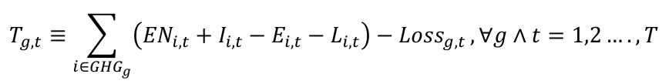
Source: Extended Day-Ahead Market Draft Technical Description

- The net GHG import transfer (T) represents the net import into a GHG area supported by market participating resources outside the GHG area, The market calculates this transfer capacity and allocates the transfer to GHG bids to ensure GHG compliances is considered consistently for all resources serving the GHG area. The GHG attribution process is described further in Section 1.2.

- Energy in the GHG area (EN): Energy in a GHG area is the sum of the schedules/output from all GHG regulation area resources, inclusive of each BAA’s resources mapped to that GHG area. These resources are not attributed because they are already accounted for and settled at GHG pricing nodes. GHG modeling for resource-specific resources is described further in Section 1.2.2.

- Load in the GHG area (L): Load in the GHG area must be met by capacity from GHG regulated resources or attributed to market resources that offer GHG. Prices at LAPs in the GHG area include the cost of GHG. Load modeling for the GHG area is described further in Section 1.2.3.

- Imports and Exports from non-EDAM/non-WEIM BAAs (I/E): Imports and exports at interties between a GHG area BAA and a non-market BAA are treated similarly as internal energy. Non-market imports can be scheduled directly into a GHG area at GHG modeled SPs that reflect the cost of GHG in the tie LMP. The market accounts for non-market imports by reducing the GHG transfer by the net import. Intertie transactions in the GHG model are described further in Section 1.2.4.

BAA-level modeling
Most BAAs do not need to update their market model for GHG purposes:
- A BAA that is fully outside the physical boundary of a GHG state will not be mapped to a GHG area. Pricing nodes will not directly reflect additional GHG costs; supply resources that participate in GHG will receive a GHG settlement for capacity attributed to the GHG area.

- A BAA that is fully within a GHG state will be included in the GHG regulation area. In-state generation will be modeled as GHG regulated resources. In-state load will be modeled within that state’s GHG attribution constraint.
The ISO expects BAAs that partially overlap with California or Washington state boundaries to coordinate with the ISO on GHG mapping. The GHG mapping procedure for multi-state BAAs is described in Section 2.

Resource association with a GHG area
Resource-specific market participating system resources are modeled as either GHG regulated or non-GHG area resources.
As a general rule, resources physically located within CA or WA state boundaries are modeled as GHG area resources, and resources outside these states’ boundaries are eligible to offer GHG capacity as non-GHG area resources. Resources under separate jurisdiction, like those under a federal power marketing administration, are modeled as non-GHG area resources.
- GHG regulated resources are permanently associated with the GHG area. These are resource-specific resources, physically located within the CA or WA state boundary and covered by the state’s GHG cap-and-trade policy. Output from resources permanently associated with the GHG area is accounted for as energy (EN) in the GHG import allocation constraint because all output is subject to regulation regardless of electrical or contractual sink. If awarded energy, these resources are priced and settled at the MEC plus MC-GHG.

- Non-GHG area resources physically located out-of-state, or are under separate jurisdictional oversight, and are not included in the GHG regulation area. This includes resources with electrical ties and/or contractual obligations to load in a GHG regulation area. These resources can submit GHG bid adders for consideration to support GHG transfers.

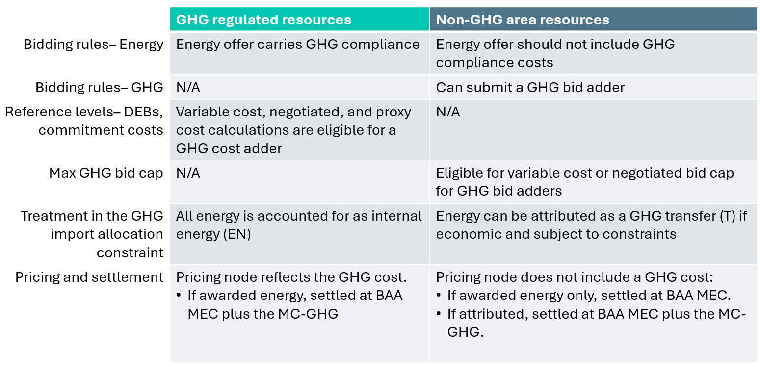
The table below summarizes and compares the treatment of GHG regulated resources and non-GHG area resources with respect to the regulated resources GHG area.

Load association with a GHG area
Load in the GHG area must be met by capacity from GHG regulated resources or attributed resources and is therefore included in the GHG import allocation constraint. Prices at LAPs in the GHG area include the cost of GHG.
In the day-ahead market, the market uses bid-in demand to define each BAA’s power balance constraint (PBC) and to define the load in the GHG area. GHG area load in the GHG attribution allocation constraint is the sum of load resource bids on LAPs associated with the GHG area.
In real time, the market defines each BAA’s PBC differently from the load in the GHG area. Each BAA’s BPA is based on the BAA’s load forecast. For load in the GHG import allocation constraint, the market will sum the load distributed to LAPs associated with the GHG area.

Intertie association with a GHG area
For BAAs fully within the boundary of a GHG area, interties will be associated with that GHG area. Ties associated with a GHG area include the cost of GHG in their LMPs.
- Interties with a non-market BAA: Non-market imports at intertie scheduling points that reflect the MC-GHG are counted as internal energy in the GHG import allocation constraint. If an EDAM or WEIM entity allows economic participation from imports on its interties, imports at interties that include GHG in the LMP should include GHG directly in the energy offer.

- Interties that allow economic participation: If an EDAM or WEIM entity allows economic participation in the FMM from imports on its interties, imports from system resources may submit a GHG bid adder at ties that are not associated with the GHG area.

- WEIM-only base transfers: Import base transfers from exclusively EIM BAAs outside GHG regulation areas to exclusively EIM BAAs that overlap with the GHG regulation area are not attributed. These imports are counted as internal energy, reducing the net GHG import.

- Interties between two market participating (EDAM/WEIM) BAAs: Energy transfer system resources (ETSRs) are optimized and attributed as GHG transfers.
A multi-state BAA can associate specific Tie IDs with a GHG area they overlap with. See Section 2.3 for more on Tie ID association for multi-state BAAs.

Requesting changes to the GHG model
The ISO expects a market participant to receive special provisions from their relevant state air regulator if they request GHG modeling that does not align with state boundaries. The ISO will model unique footprints in line with state regulator’s understanding.
- Section 2 details the procedure for EDAM/WEIM Entities to request changes to BAA-level modeling; this procedure facilitates modifications to supply resource association, load association, and Tie association.

GHG bid eligibility and verification
Non-GHG area resources make capacity available for GHG attribution by submitting a GHG bid. This hourly bid adder indicates what portion of the resource the SC wants to make available for attribution, and the $/MWh cost of GHG compliance they want to recover through the market.
The market verifies the $/MWh GHG bid adder and the portion of each resource’s bid-in capacity that is eligible for GHG attribution.
This section highlights two features of the verification process that require entities provide the ISO with resource-specific GHG information: the max GHG bid cap verifies the $/MWh bid adder, and GHG counterfactual verifies capacity eligibility.
- Section 4 provides registration instructions for SCs to manage their GHG bid cap and counterfactual schedules.

Max GHG bid cap
GHG bid adders are verified against a cap to provide a reasonable assurance that GHG bids are cost-based offers. The cap is calculated with each resource’s emissions rate registered in the Master File. If the field is left blank, the cap for that resource’s GHG bid will be $0/MWh.
The max GHG bid cap is a resource-specific cost-based calculation. The market calculates a daily max GHG bid cap for each resource and for each GHG regulation area.
The max GHG bid cap is a cost-based formula that estimates a resources maximum compliance cost per MWh. There are two options—variable cost and negotiated:
- The variable cost option estimates the resource’s maximum cost of compliance using the resource’s highest average heat rate and emissions rate registered in the Master File, and a daily GHG allowance price.

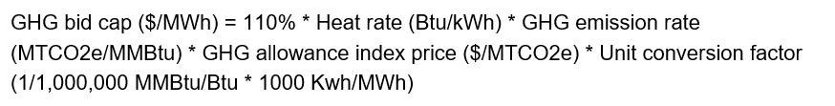

- Under the negotiated option, an SC can request a negotiated emissions rate that varies with the daily GHG index price, or a static $/MWh value that does not change on a daily basis with the GHG index price.

Both the variable cost and negotiated options leverage a GHG allowance price index. The GHG allowance indices for CA and WA, posted daily on OASIS, represent the average of the most recently available allowance price from Argus and the Intercontinental Exchange (ICE).

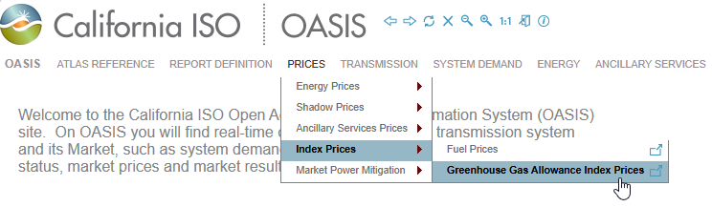

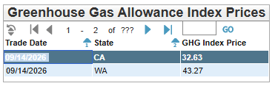

The max GHG bid cap is calculated and published by 8:50am PT before the Day-Ahead Market.

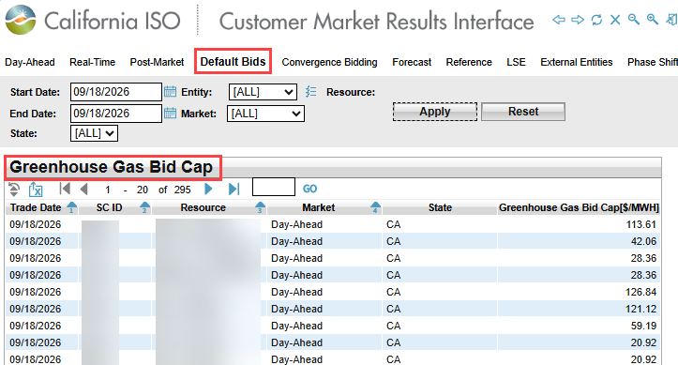

References: Tariff section 33.32.1.5 “Determination of Maximum GHG Bid Adder”, BPM for EDAM Section 23.2.5 “Maximum GHG Bid Adder”, BPM for Market Instruments Attachment K “Greenhouse Gas Allowance Price Calculation”.

GHG Counterfactual
Attributing GHG transfers to resources that could otherwise support load outside of a GHG regulation area carries a risk of “secondary dispatch”. Each resource’s eligible GHG capacity is limited to support accurate GHG accounting.
is the market limits a resource’s attributable capacity by a resource-specific counterfactual schedule. The counterfactual is an estimate of that resource’s capacity that would have been dispatched even without GHG area demand.
Counterfactual methodologies differ by market participation—EDAM vs WEIM-only—and by market run:
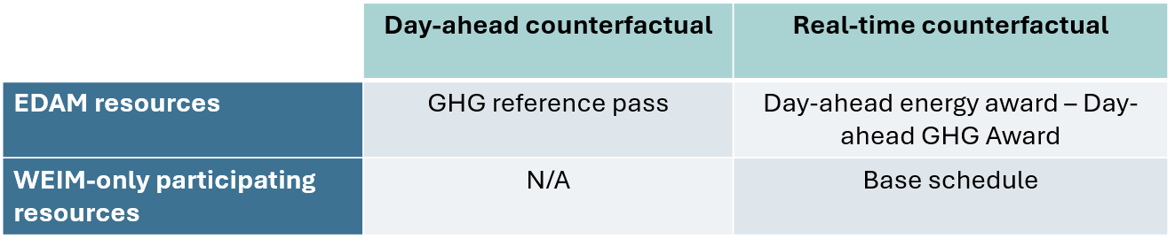

- WEIM-only only entities can use self-submitted base schedules and base transfers to schedule capacity committed to load.

- In EDAM, the market runs a GHG reference pass as part of the Day-Ahead Market process. This dedicated market pass uses the FNM to produce counterfactual schedules for EDAM participating resources. Each EDAM participating resource receives its own counterfactual, also called the GHG reference point.
SCs can view the results of the GHG reference pass in CMRI:
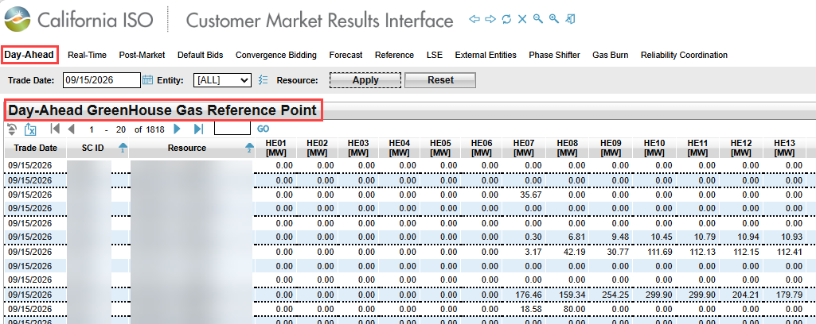
References: BPM for EDAM Section 23.3.3 “GHG Reference Pass”, Tariff Section 33.32.2.3

1.3.3 Committed Capacity
“Committed capacity” in the GHG model is capacity with a load off-taker in a GHG area. Attributing committed capacity does not create secondary dispatch. SCs must self-identify committed capacity associated with a resource.
WEIM entities can include committed capacity in base transfers or economically offer committed capacity for attribution in the WEIM. Committed capacity extends this self-submit capability to EDAM participants.
- Section 4.2 provides instruction for committed capacity registration. Registered committed capacity is excluded from the GHG reference pass to ensure the resource is eligible for GHG attribution.

- Section 5.3 instructs SCs on bidding committed capacity in SIBR. Committed capacity must be offered into the market with a GHG bid adder. While exempt from counterfactual constraints, committed capacity is still subject to economic dispatch.

1.4 GHG Attribution
The market optimally allocates the net GHG import—denoted as (T) on the left hand side of the GHG import allocation constraint—to market resources that submit GHG bid adders. The market will do GHG attribution and determine a GHG cost for each GHG area separately.
- The shadow price of the GHG allocation constraint is the marginal GHG Cost for the respective GHG Regulation Area, described in Section 1.4.1 below.

- Resources attributed to the GHG area receive an Export Allocation for that state and are settled at the marginal GHG cost.

Attributed resources are associated with the entire GHG area and must follow the state’s compliance and reporting rules for attributed resources. The GHG model does not identify and attribute resources to specific loads or specific BAAs within the GHG area.

See CMRI for CA Export Allocation under Real-Time Dispatch (RTD) Schedules:
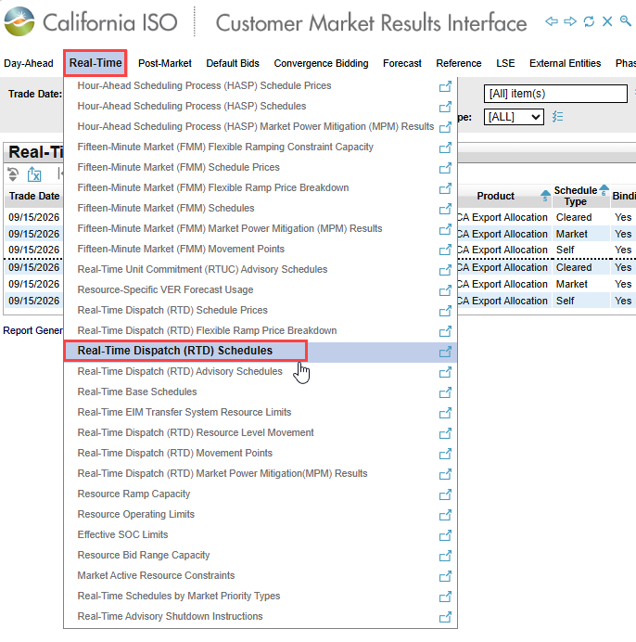
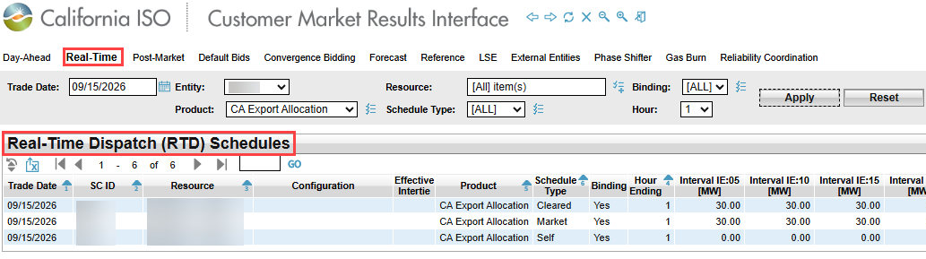

1.4.1 Marginal cost of GHG
GHG awards are based on the marginal cost of GHG (MC-GHG). The MC-GHG is the shadow price of the GHG import allocation constraint.

- The MC-GHG is positive when there’s a difference in the cost of meeting load in the GHG area versus the non-GHG area due to GHG compliance.

- The MC-GHG is zero when the least cost solution for both the GHG and non-GHG areas is the same. For example, the MC-GHG is zero when the GHG area is net exporting capacity that minimizes costs universally. In this case, an increment of load in the non-GHG area would cost the same as an increment of load in the GHG area.

If a resource is attributed and receives a GHG award, the energy award plus the MC-GHG will cover the resource’s energy offer plus GHG bid. Conceptually similar to congestion, this cost is independent from, and in addition to, energy costs. A resource can only receive a GHG award up to their energy award. For the capacity of the GHG award, the resource is settled the BAA MEC plus the MC-GHG for the relevant GHG area.
GHG revenue collected from load in a GHG area covers:
- all GHG compliance costs of resources dispatched to serve the GHG area—internal resources and attributed resources.

- Energy costs in excess of the LMP in the non-GHG area.

See OASIS for Greenhouse Gas Shadow Prices:
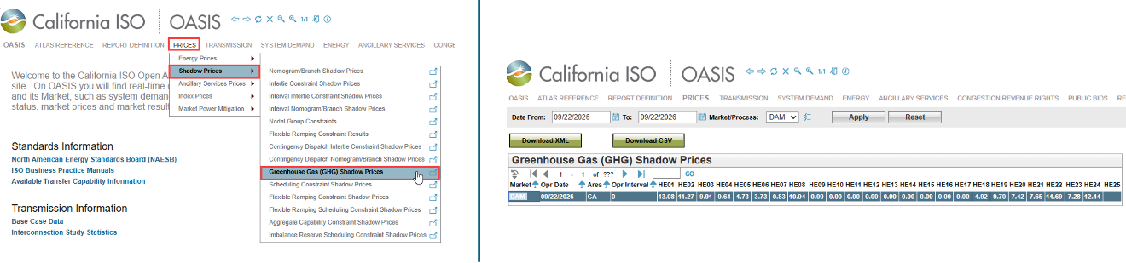

See CMRI Commodity Reports to view the GHG portion of the LMP. This report may be sorted by Price Type to show just the Greenhouse Gas values.
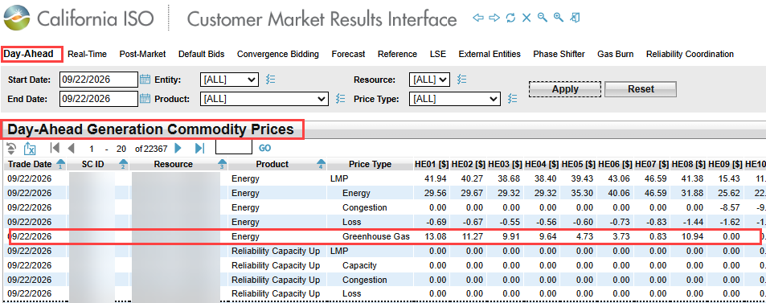

GHG Mapping for multi-state BAAs
The information in this section is preliminary and subject to change as project plans and requirements are further developed.

This section describes the GHG mapping procedure for WEIM and EDAM BAAs whose service area partially overlaps with California or Washington state boundaries. This includes BAAs under federal jurisdiction that have special arrangements with their state regulators to exempt certain assets from the GHG model.
Modeling the GHG area’s geographic boundary is the process of mapping certain pricing nodes for resources and load covered by a GHG state’s jurisdiction to a GHG regulation area in the market model. Entities can provide the ISO with geographic data, and/or asset specific modeling requests to customize how the BAA is situated.
Entities that overlap with CA or WA that are not pursuing GHG mapping for Jan 1 go-live should reach out to their client representative or stakeholderaffairs@caiso.com to confirm intent and establish an alternative schedule.
To initiate GHG mapping, the EDAM or EIM entity should submit a CIDI ticket including the following requirements:
- Geographic data, Section 2.2
- Load modeling, Section 2.3
- Supply resource modeling, Section 2.4
- Intertie modeling, Section 2.5
References: EDAM BRQs 02141, 02143

Why GHG mapping matters
For a BAA that partially overlaps with a GHG area, GHG mapping enhances market participation benefits by shifting the responsibly of GHG cost allocation to the market:
- Alleviates undue charges to load outside the GHG regulation area by assigning GHG costs to responsible GHG area load.

- Creates a level playing field for out-of-state and GHG regulated resources to compete for market awards.

- Shifts the compliance obligation to the attributed market resource.

- Improves transparency and efficiency of out-of-market imports by specifying BAA interties that sink into the GHG area.

GHG Mapping does not impact other BAA-level obligations or modeling. For example, GHG mapping does not impact:
- The Power Balance Constraint (PBC): the market enforces a power balance constraint at the BAA-level and produces a BAA-level MEC.

- WEIM-only entity base schedules and the Resource Sufficiency Evaluation (RSE).

- For EDAM entities, load forecasts used in day-ahead market operations and the day-ahead RSE.

Geographic Data
Entities must provide a complete substation-to-state mapping list. The ISO will use this information to map supply and load to a GHG area, perform network analysis and calculate losses.

Load Modeling
The ISO will use the geographic data provided by the market participant to establish new Custom Load Aggregation Points (CLAPs) to represent load in a GHG area separately from load in the non-GHG area.
The information in this section is preliminary and subject to change as project plans and requirements are further developed.

Supply resource modeling
The ISO will use the geographic data provided by the market participant to identify and map supply resources to the GHG area. Supply resources mapped to the GHG area will be modeled as GHG regulation area resources, as described in Section 1.2.3.
Entities can also request GHG mapping by Resource ID. An entity or resource SC can request that the ISO model unique circumstances, e.g. regulation that not align with state boundaries. The ISO expects these requests to align with the relevant state air regulator’s understanding. SCs should make sure that a resource’s GHG area association does not conflict with or pose problems for contractual arrangements including energy pseudo-tie agreements.

2.5 Intertie modeling
Entities can consider GHG modeling for interties. A multi-state BAA can identify scheduling points (SPs) for imports into the GHG area versus non-GHG area SPs.

Offering GHG Capacity
This section outlines best practices and addresses common questions about offering capacity for consideration in GHG attribution.
For resources physically located outside a GHG regulated state, participation in GHG is voluntary. Resources that offer capacity into a GHG area accept responsibility for compliance and reporting obligations to the relevant state agency for capacity identified by the market as a transfer into the GHG area.
Checklist for SCs managing resources either in a GHG area or intending to offer GHG capacity:
- Review best practices. Make sure resources’ GHG area association is consistent with state jurisdiction, and with contractual agreements like energy pseudo-tie arrangements.

- Update resource specific GHG emissions and committed capacity information in the Master File. Generator Resource Data Template (GRDT) registration is described in Section 4.

- Submit GHG bids. Review step-by-step process for submitting GHG bids in Section 5.

- Fulfill reporting and compliance obligations. Section 6 offers instructions for finding and extracting data that SCs may be responsible for.

Why offer GHG capacity?
Market participants offer GHG capacity for the opportunity to receive GHG awards. GHG awards provide revenue in addition to the energy award. GHG revenue is funded entirely by load in the GHG area. This design can simultaneously increase revenue for supply participating in the GHG model and decrease costs to load in non-GHG areas.

What can you bid?
When offering capacity into a GHG area, a SC can select the capacity value (MW) and bid adder value ($/MWh).
- Capacity value (MW): SCs can make available any capacity value between the lower and upper economic limit. SCs should coordinate with their supply off-takers to understand how GHG relates to their arrangements. SCs should make sure that GHG attribution does not conflict with or pose problems for obligations under their state’s regulations.

- Bid adder value ($/MWh): SCs can use the GHG bid adder to reflect and recover their expected compliance costs; this value can reflect a resource owner’s own valuation of GHG compliance obligations or financial strategy for purchasing GHG allowances. The bid adder must be non-negative and is only limited by the max GHG bid cap.

WA FAQs

- Can an entity offer a resource for participation in the GHG market model and retain renewable attributes under WA’s Clean Energy Transformation Act (CETA)?
Yes. The entity can retain a resource’s renewable attributes if the resource is either 1) dispatched by the market as unspecified energy, i.e. does not receive a GHG attribution, or 2) receives a GHG attribution to the WA GHG area.
Receiving a GHG attribution to the CA GHG area is considered “double counting”.
There is no double counting if a resource receives a GHG attribution to the WA GHG area. GHG attribution does not make a resource available to a specific WA utility for load-based compliance. Similarly, a resource physically located in WA State is accounted for as energy in the WA GHG area but is not attributed to a specific entity in the GHG area for load-based compliance.

- Does a resource have to receive a GHG attribution to the WA GHG area for a WA entity to claim the resource’s renewable attributes under CETA?
No.

Master File registration
This section provides instructions for registering GHG emissions information and committed capacity in the Master File.
The Generator Resource Data Template (GRDT) has two tabs specifically related to the GHG model:
- GHG_Emissions_Rate: This tab allows SCs to register a resource’s emissions rate for each GHG area. This information is used in market operations.

- GHG_Contract: This tab is applicable to non-GHG area resources with capacity obligations in a GHG area.
References: BPM for Extended Day-Ahead Market, Section 23.2.5, BPM for Market Instruments Attachment B and K

GHG Emissions Rate
Per resource ID, the SC should fill out the GHG_Emissions_Rate tab with emissions information for each GHG regulation area.
State | WA | CA
GHG Emissions Rate | Pending further details | Pending further details
GHG Compliance Obligation | Y: If Y is selected, the market will use the GHG emissions rate in the WA GHG emissions rate field to calculate the GHG cost adder in reference levels for applicable WA GHG area resources, or the max GHG bid cap for resources eligible to submit a GHG bid adder for the WA GHG area.  N: if N is selected, the market will use $0/MWh as the GHG cost for reference levels and the max GHG bid cap. | Y: If Y is selected, the market will use the GHG emissions rate in the CA GHG emissions rate field to calculate the GHG cost in reference levels for CA GHG area resources, or the max GHG bid cap for resource eligible to submit a GHG bid adder for the CA GHG area.  N: if N is selected, the market will use $0/MWh as the GHG cost for reference levels and the max GHG bid cap.
GHG Pseudo Tie ** | Selecting Y triggers a process to permanently associate the resource with the WA GHG area. ** | Selecting Y triggers a process to permanently associate the resource with the CA GHG area.**

**This reflects the current process; participants should monitor the Proposed Revision Request (PRR) process for updates and opportunities to provide comments on proposed changes.
The SC can register two separate sets of GHG emissions information per resource—one for each State. A resource’s GHG emissions information for WA and CA may differ if, for example, there are differences in the two state’s reporting rules or if an entity chooses to use a negotiated or ACS rate for one state but not the other.
The table below summarizes how the registered emissions rates will be used in market operations depending on the resource’s GHG area association:
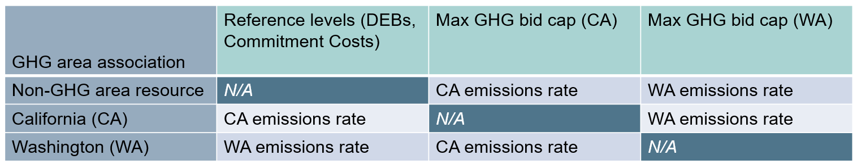

Negotiated Rates
An SC can request a negotiated emissions rate that varies with the daily GHG index price, or a static $/MWh value that does not change on a daily basis with the GHG index price.
Entities can use the negotiated process to request an asset controlling supplier (ACS) rate.
To negotiate a GHG bid cap, the SC may submit a CIDI ticket with case record type “Negotiated Rate Application” and Application type “Other”.

GHG Contract Data
The GHG contractual information field lets SCs self-identify committed capacity—capacity that should be withheld from the GHG reference pass and made available for GHG attribution.
The system will validate that the registered capacity does not exceed the resource’s Pmax, and that the total contractual capacity of a resource registered to both GHG areas does not exceed the resource’s Pmax.
Contract information will become available in SIBR after 5-10 business days.

Submitting GHG bids
This section instructs SC on submitting GHG bids in SIBR.

Submitting an Energy Bid
A GHG bid must be accompanied by an energy offer. The energy offer can be economically bid or self-scheduled.
Resources in a GHG regulation area are expected to use their energy offer to carry GHG compliance costs and do not submit additional GHG bids for their native GHG area.
Both GHG regulated resources and non-GHG area resources submitting energy bids can associate the resource’s offer with other market products including transmission rights and CRN entitlements.

Submitting a GHG bid
GHG is an hourly bid component that can be submitted on top of an economic energy offer or self-scheduled energy offer.
Three fields must be completed to submit a valid GHG bid: Two bid components—GHG capacity (MWh) value, and GHG bid adder ($/MWh) value—and the GHG area.
Currently, if bids are being submitted via an Application Programming Interface (API), users should visit the Developer Portal as soon as possible and review the v5 API Specification and XML Schema Definition XSD and share these materials with applicable vendors to complete necessary updates. Another way to represent a GHG capacity and price is through the Scheduling Infrastructure and Business Rules User Interface (SIBR UI) where users need to copy bids forward, ensuring you supply the GHG area.
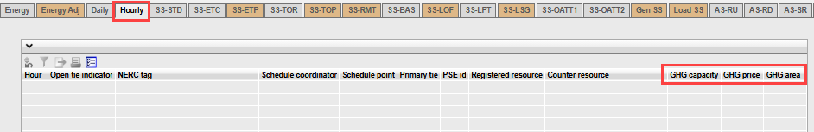
GHG capacity (MW) signals the capacity from this resource the SC is willing to offer for attribution to the GHG area.
- 0MW or null will not trigger bid validation or submission. The market will only consider non-zero MW bids.

- The GHG bid capacity is independent of the submitted energy bid curve but is limited by the maximum MW quantity represented in the submitted energy bid curve.

- The GHG bid capacity is independent of GHG contractual capacity.

The GHG bid adder ($/MWh) carries the GHG compliance obligation.
- SIBR will not validate the GHG bid if this field is left blank. To submit a $0/MWh bid adder, the SC must enter $0/MWh.

- Offers can range from $0/MWh and the resource’s specific max GHG bid cap for the indicated GHG area.

- The sum of the GHG bid adder and the Energy Bid price may not exceed the soft offer energy bid cap, unless the sum of the max GHG bid adder and revised DEB exceeds the soft offer cap.

The GHG area association designates the GHG bid as an offer to either the CA or WA GHG area.
- Resources in the CA GHG area will not be able to submit a GHG bid for CA, and WA for WA.

- A resource can submit the full UEL to both CA and WA, and the market will optimally allocate the capacity.

Submitting GHG bids for multiple GHG areas
Resources outside both WA and CA GHG areas will have the option to submit a GHG bid for each GHG area. If the resource offers capacity to both GHG areas simultaneously, the market will optimally attribute the GHG capacity.
GHG regulated resources will have the option to submit a GHG bid for the GHG area separate from the one they are associated with. These resources are still expected to use their energy offer to reflect compliance costs associated with their native GHG area in addition to submitting a GHG bid adder for the separate GHG area. If attributed to the separate GHG area, the resource must fulfill the compliance and reporting obligations for both states.
The table below shows examples of how different resource associations can use GHG bids.
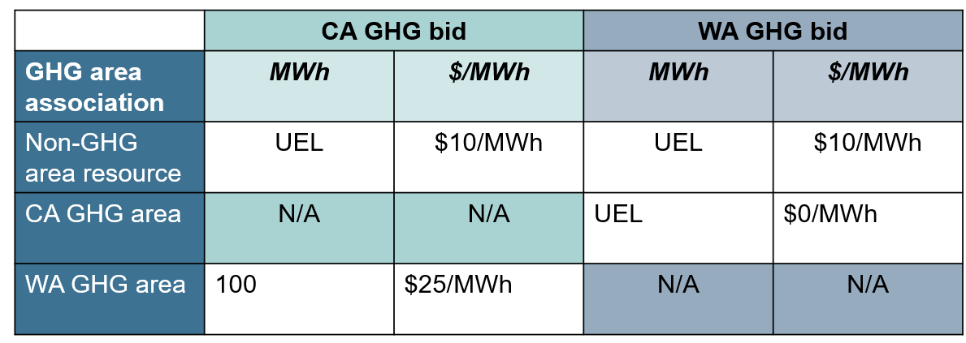

Bidding Committed Capacity
Committed capacity is exempt from the GHG reference pass. Resources with registered committed capacity offer this into the GHG area by submitting a GHG bid.
- Section 1.3.3 and Section 4.2 describe committed capacity and registration.

The SC can use the GHG bid adder to dynamically modify the committed capacity they want to make available to the GHG area on an hourly basis.
The example in the table below illustrates how an SC can use the GHG bid to modify the eligibility of committed capacity. The example shows a resource with 100MW upper economic limit (UEL).
- Capacity eligible to receive a GHG reference schedule is the UEL – registered committed capacity. Committed capacity will receive a 0MW reference schedule. Capacity not registered as committed capacity will be considered in the GHG reference pass.

- Capacity eligible for attribution is the UEL – GHG reference schedule.
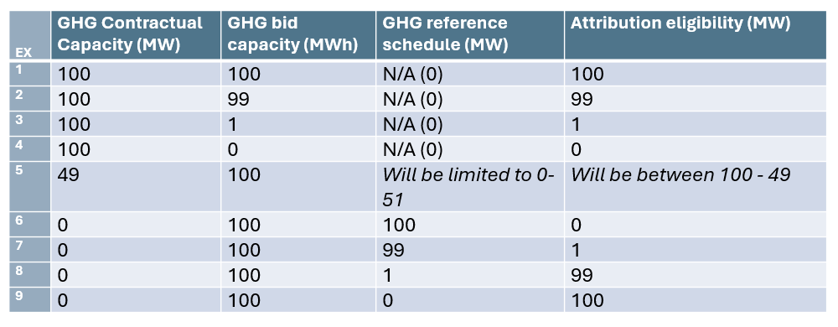
In Examples 1-4, the full capacity of the resource, up to it’s UEL, is registered as committed capacity. These examples illustrate how an SC can flexibly manage a load obligation by submitting the maximum potential capacity commitment in GRDT, and using the GHG bid to dynamically modify the precise MW commitment on an hourly basis. In example 1, the SC offers the full committed capacity into the GHG area with a GHG bid adder. In example 4, the SC does not offer the committed capacity and will not receive a GHG attribution.
- Committed capacity that is not offered with a GHG bid adder, as in example 4 above, will not be considered for attribution.
In example 5, the resource is partially registered as committed capacity. If the full UEL of the resource is bid with a GHG bid adder, the portion that is registered as committed capacity (49MW) will not receive a GHG reference schedule. The resource may receive up to 51MW GHG reference schedule. The 49MW of committed capacity plus any remaining capacity that does not receive a reference schedule is then eligible for GHG attribution.
In examples 6-9, the resource is not registered as committed capacity. The capacity eligible for GHG attribution depends entirely on the results of the GHG reference pass.

Scheduling at GHG Ties
This section is under development and will be updated as conditions evolve.

Reporting
This section is under development and will be updated as conditions evolve.

Appendix A: LMP Decomposition Updates as of 05/01/2026

The method of LMP decomposition and location of GHG information has changed.
- Before May 1, 2026 enhancements, the MC-GHG was visible as part of WEIM entity LMPs on OASIS and in CMRI.
Prior to EDAM go-live, LMPs were based on the system marginal energy cost (SMEC) measured at a reference bus in California. Due to the location of the reference bus, GHG was embedded in the SMEC. The MC-GHG component had to be subtracted out to calculate LMPs for non-GHG areas, but added back in again to represent the total award for attributed resources in non-GHG areas.
- Today, the MC-GHG is posted separately on OASIS and in CMRI
Today, LMPs are decomposed from a marginal energy cost (MEC) for each BAA. The MEC is the shadow price of the BAA’s power balance constraint. The MC-GHG is calculated the same way as before, as the shadow price of the GHG import allocation constraint, but printed separately from LMPs in non-GHG areas. This simplifies pricing and settlement calculations without impacting outcomes.
The policy and logic of GHG awards, charges, and settlement have not changed. Resources with a GHG compliance obligation—resources dispatched in the GHG area, and resources attributed to the GHG area—are similarly awarded the MC-GHG. Load outside a GHG area is never charged the MC-GHG.
The chart below offers a simplified example of LMP decomposition based on a single SMEC and BAA-specific MECs.

Appendix B: Acronyms

Term/Acronym | Definition
ACS | Asset Controlling Supplier
BAA | BAA Balancing Authority Area
BPM | BPM Business Practice Manual
CARB | CARB California Air Resources Board
CLAP | CLAP Custom Load Aggregation Point
CMRI | CMRI Customer Market Results Interface
DEB | DEB Default Energy Bid
ECY | ECY Washington Department of Ecology
EDAM | EDAM Extended Day-Ahead Market
ELAP | External Load Aggregation Point
EN | EN Energy
ETSR | ETSR Energy Transfer System Resource
GHG | GHG Greenhouse Gas
GRDT | GRDT Generator Resource Data Template
ICE | ICE International Exchange
IFM | IFM Integrated Forward Market
LDF | LDF Load Distribution Factors
LMP | LMP Locational Marginal Price
MC-GHG | MC-GHG Marginal Cost – Greenhouse Gas
MEC | MEC Marginal Energy Cost
MRI-S | MRI-S Market Results Interface - Settlements
OASIS | OASIS Open Access Same-Time Information System
PBC | PBC Power Balance Constraint
PRR | PRR Proposed Revision Request
PT | PT Pacific Time
DAM | DAM Day-Ahead Market
RSE | RSE Resource Sufficiency Evaluation
RTM | RTM Real-Time Market
SC | SC Scheduling Coordinator
SIBR | SIBR Scheduling Infrastructure and Business Rules
SMEC | SMEC System Marginal Energy Cost
SQMD | SQMD Settlement Quality Meter Data
UEL | UEL Upper Economic Limit
WEIM | WEIM Western Energy Imbalance Market

Prior to EDAM go-live, the method of LMP decomposition resulted in a negative GHG price component at pricing nodes outside a GHG area. The LMP decomposition method and the location of GHG information has since changed. Appendix A describes the nature and impact of this change. Section 1.2.1 describes where SC can find the GHG component on OASIS and in CMRI.
The ISO Tariff defers to the relevant state regulatory authority to define the policy’s jurisdiction.
“EDAM Final Proposal” (2022) Page 95. https://stakeholdercenter.caiso.com/InitiativeDocuments/FinalProposal-ExtendedDay-AheadMarket.pdf
Additional limits and constraints ensure GHG attribution respects physical supply characteristics and results in feasible outcomes. See BPM for EDAM Section 23.3: Consideration of Eligible GHG Capacity in Market Clearing.
For GHG regulation area resources, the market may include a GHG cost adder in default energy bid (DEB) and commitment cost reference levels. A max GHG bid cap is not applicable to these resources.
In the past, stakeholders expressed concerns with the GHG accounting framework that the market’s cost minimization objective may lead to the attribution of transfers to lower emitting resources, thereby leaving high emitting resources to “backfill” to serve load not subject to a GHG pricing program. This potential for secondary dispatch raises a concern that the GHG pricing program is not accurately accounting for the emissions caused by load subject to the GHG pricing program.
WEIM entities can view their base schedules in the Base Schedule Aggregation Portal.
With secondary dispatch there is no actual change in the mix of generation dispatched and no price signal transparent to the market, but instead a re-alignment between energy dispatched and the responsible consumer. An administrative procedure is necessary to estimate when secondary dispatch most likely occurs.
The MC-GHG is a separate and distinct concept from the GHG allowance price and may not always appear equal. States with GHG pricing policies have mechanisms to determine the cost of GHG compliance in their jurisdiction, e.g. an allowance auction. Market participating resources reflect their expected compliance costs in the market. The MC-GHG, a result of the market optimization, makes transparent difference between the marginal energy cost in the GHG area and non-GHG area. This different may reflect the GHG area’s preference for a more expensive but clean resource; in this case, the MC_GHG would reflect the difference in energy costs between the clean resource being attributed and the clearing price in the non-GHG area and does not represent a compliance cost.
The EDAM Final Policy refers to this feature as the “Geographic Boundary” enhancement. Both the policy and the Tariff provide flexibility around the definition of the GHG area in the market model to accommodate circumstances where the state’s policy footprint does not align with the state’s boundary.
Entities whose load and resources are located fully within, or fully outside, Washington or California state boundaries can request GHG mapping modifications through the procedure in this section. As noted in Section 1.2.4, the ISO expects a market participant to coordinate with their relevant state air regulator if they request GHG mapping that does not align with state boundaries.
See WAC 480-100-670 (8) “Use of renewable energy credits other than unbundled RECs to comply with the greenhouse gas neutral standard”
Tariff Section 33.32.2.3, “The GHG reference pass will not schedule capacity located outside of a GHG regulation area obligated to serve demand within a GHG regulation area that is registered with the CAISO in accordance with the applicable Business Practice Manual, thereby allowing this capacity to support a GHG transfer into a GHG area in the IFM”. Also see BPM for the Extended Day Ahead Market section 23.3.1.1.

