The ISO received comments on the topics discussed at the January 29, 2025 stakeholder meeting from the following:

1. ENGIE NA (“Engie”) 2
2. Longroad Energy 3
3. Wellhead Electric Co. Inc. 3
4. California Public Utilities Commission (CPUC) 5

Copies of the comments submitted are located on the Miscellaneous Meetings Page under Transmission Development Forum at:
https://www.caiso.com/library/transmission-development-forum

The following are the ISO and PTO’s responses to the comments.

ENGIE NA (“Engie”)
No | Comment Submitted | Responses
a | During PG&E's presentation of slides 17 and 18, slides that review specific Deliverability Network Upgrades for which In Service has been delayed (since the last report) by 3+ or 6+ mo, respectively, PG&E identified errors in its posted report w/ respect to the "C12P2 LDNUs", Delivery Network Upgrades in the Ripon-Manteca-Stanisluase area (see table below). Specifically PG&E indicated that, although the "overlap" scope had been reduced, at the at least one of the identified C12P2 LNDUs now has an In Service date of in Q2 2030--a significant delay not reflected in the posted materials. Overall the C12P2 LNDU are now delayed by 2-5 years compared to the schedules originally offered at the time when generators committed to fund these projects.  Engie requests that PG&E update its pages in in "network-upgrades-generator-interconnection-jan-2025.xlsx" by no later than 3/15/2025 or, as it offered during the TDF, accept requests to meet with impacted stakeholders before the next TDF and provide additional information on schedules related to these upgrades that have an important impact on project deliverability and available Resource Adequacy capacity in the state. | PG&E RESPONSE:  There are significant dependencies between the C12P2 LDNU reconductoring projects in the Ripon, Manteca, Riverbank, Melones, Stanislaus areas. Carefully planning these projects requires us to consider:  - Permitting, the first permitted projects have been sequenced first even though those are multi-year work scopes broken down into several phases. Later permitted projects are sequenced to follow.  - Allowed clearance windows to take outages on the lines for upgrades. This means each project will have its construction window in specific months of the year without the ability to perform more than one of these LDNUs at a time. Given the lengths of these projects and that several have double circuits, PG&E must take extra measures to construct to mitigate outages on related lines.  - Safely balancing Local load impacts in the area.  - Scope of upgrades, (Towers and line upgrades or just line upgrades). More than one project has tower and line replacements.  - Resistance by area landowners to allow PG&E to increase rights to account for the conductor blowout requirements. Negotiating land rights is part of these projects.  - Area weather and emergency response impacts. With significant weather events recently, there are some impacts to schedule.  - Scheduling, once projects are fully through with engineering, and permitting, they are scheduled for clearances. Thise is often the reason why there is realignment among area project In-service dates.  PG&E is open to disclosing related information through the CAISO.  Phase 2A1-1321 001/008 to 010/065 FISD Nov 2024  Phase 2B1-8600 001/008 to 010/064 FISD 12/2025  Phase 2A0-7840 Substation Work FISD 12/2026  Stanislaus-4523 Sub Work FISD 12/2026  Phase 2B0-7842 Sub DE to 001/007 FISD 12/2026  Phase 2A2-7841 010/066 to 018/115 FISD 12/2027  Phase3-3341 Melones Tap FISD 12/2027  Phase 2B2-7843 010/065 to 018/108 FISD 12/2028 (Summer) C12P2-LDNU3-5471 Bellota-Riverbank-Melones Sw Sta 115 kV Line 115 kV Line FISD 02/2028  C12P2-LDNU1-5469 Ripon-Manteca 115 kV Line FISD 04/2028 C12P2-LDNU4-3341 Stanislaus-Melones SW STA-Riverbank Jct Sw Sta 115 kV Line FISD 01/2029  C12P2-LDNU2-5470 Stanislaus-Melones Sw Sta-Manteca #1 115 kV Line 07/2029  Phase 2C-1241 018/116 to 030/195 FISD 04/2030 (Winter) Phase 2D-1242 018/109 to 035/212 FSID 04/2031 (Riverbank Jct Tap)

Longroad Energy
No | Comment Submitted | Responses
a | Can CAISO and PG&E clarify the difference between the New Manning 500 kV substation TPP upgrade (T.009189) and the New Manning 500 kV substation RNU upgrade (C14P2-NFT02)? | PG&E RESPONSE:  There is no difference between the New Manning 500 kV substation TPP upgrade (T.009194) and the New Manning 500 kV substation RNU upgrade (C14P2-NFT02). C14P2-NFT02 will be achieved with completion of the entire scope for T.0009194.
b | What is the difference in scope between T.009189 and C14P2-NFT02? | PG&E RESPONSE:  The New Manning project is under T.0009194, and not T.0009189. Please refer to subpart for the difference in scope between T.0009194 and C14P2-NFT02.
c | Why are the In-Service dates different for the two line items (4/1/2028 for the TPP upgrade and 6/1/2028 for the RNU)? | PG&E RESPONSE:  At the time of the TDF pull, PG&E was in the process of aligning the project schedule of T.0009194 with LS Power. The difference in in-service dates is a result of this transitional period. As of 3/11/25, the PG&E in-service date for T.0009194 and C14P2-NFT02 is 4/1/28.
d | If a project has the New Manning 500 kV substation as a TPP PNU (required for deliverability), but not as an RNU, will the project be granted FCDS upon the earlier in-service date (4/1/2028)? | FCDS will be will be awarded to projects that have received TPD allocation when all of the identified network upgrades to achieve deliverability are in-service.

Wellhead Electric Co. Inc.
No | Comment Submitted | Responses
a | With respect to the Summary of SCE Network Upgrades presented at the Transmission Development Forum (TDF) on Jan 29, 2025, we would offer the following comments and questions:  Per the slide shown below, Project ID SCE-C12P2-N-R3 “Moorpark CRAS: monitoring infrastructure”, we note that the In-Service Date has been moved from December 2027 to June 2028. During the TDF, it was described by SCE that the delay in the In-Service Date was tied to a Cluster 12 project that has been placed in suspension under the terms of its LGIA. | SCE RESPONSE:  Thank you for your comments and questions regarding the Moorpark CRAS network upgrade. We understand your concerns about the revised in-service date and its potential impact on later-queued projects.  The Cluster 12 project is proceeding in accordance with its interconnection agreement and within the timeline afforded by the CAISO tariff. The timing of the network upgrade is tied to the development status of the responsible project(s), and any changes to the in-service date must align with the tariff provisions governing project suspensions and restarts.  We recognize the challenges this may present and will continue to coordinate closely with CAISO and affected parties to evaluate potential solutions. This includes the possibility of allowing later-queued interconnection requests to advance upgrades triggered by earlier projects, as permitted under the CAISO tariff.
b | While the delay in the Cluster 12 project may make this change seem acceptable, there is at least one later queued project that is reliant upon this Network Upgrade and the delaying of the Moorpark CRAS has a severe adverse consequence to the later queued project.
c | Please explain why it is acceptable to place stress on a later queued project that is reliant upon this network upgrade? As we understand it, the Cluster 12 project has a responsibility to keep this Network Upgrade moving forward so as to not impact later queued projects.
d | The later queued project is seeking to have a June 2027 COD with its offtake counterparty and this delay is a serious problem that cannot be solved with a limited operational study or construction sequencing.
e | We would propose moving the Moorpark CRAS back to an In-Service date of June 2027. The resulting timeframe would be 30 months which is an adequate amount of time as we understand it.

California Public Utilities Commission (CPUC)
No | Comment Submitted | Responses
a | The Forum is intended to provide increased transparency and public awareness of ongoing transmission development timelines and to facilitate the timely identification of technical and project scheduling issues. Proactively resolving these issues can help reduce avoidable project costs and mitigate scheduling delays for needed transmission additions.  The biannual Forum presentations and workbooks would benefit from the PTOs providing more transparency on the type and timing of regulatory licensing that will be pursued. As was discussed at the meeting, it was unclear whether a status of “Exempt” reflects that a project required no CPUC permitting at all (including advice letter notice of construction) or that it just meant that the project would not require a CPCN or PTC permit. This information is also specified in Column K in the Network Upgrades Generator Interconnection spreadsheet under heading “Expected CPUC Permit Application” and Column R in the Approved Projects Transmission Planning Process under the heading “Expected CPUC Permit Application Filing.” The data provided in these fields often includes entries such as TBD, N/A, Exempt, and Pending with no definitions or descriptions.  In order for stakeholders to effectively track the regulatory status and progress of CAISO approved transmission projects, Cal Advocates recommends that the CAISO and the Transmission Owners update the regulatory status columns to include information that clarifies the specific licensing process that each transmission project will follow, including the type of CPUC filing (whether CPCN, PTC, or Advice Letter), or exemption if warranted, and expected dates for filing | PG&E RESPONSE:  TPP: PG&E recommends using the same terminology as in TPR process: 1. TBD (scoping has not progressed to the point where PG&E can determine if NOC/PTC/CPCN are needed); 2. NOC/PTC/CPNC (AL or filing number included, expected filing if not); 3. N/A (NOC/PTC/CPCN are not subject to GO 131-E NOC, PTC or CPCN requirements)  SCE RESPONSE:  Per SCE’s understanding the spreadsheets and columns referenced in the CPUC’s comment 4a are Excel Sheet Column J in the NetworkUpgrades-GeneratorInterconnection-Jan2025 Excel Sheet, and Column R in the ApprovedProjects-TransmissionPlanningProcess-January2025.  The “Exempt” status in Column R means that the project would not require a CPCN or PTC permit. SCE has not entered a “TBD” in either column referenced above. An “N/A” entry typically indicates that SCE anticipates no construction activity for infrastructure operated at 50 kV and above. However, an “N/A” entry has also been used interchangeably with “Exempt” to indicate that the project would not require a CPCN or PTC permit. A “Pending” entry indicates that SCE is in the process of preparing a CPCN or PTC application or is in the process of determining if an Exemption applies, based on GO-131-E.  SCE supports standardizing the terminology used in the TDF to the extent possible to enhance clarity and consistency. This will help effectively track the regulatory status and progress of transmission projects approved by the CAISO.  SDGE RESPONSE:  SDGE has updated the Expected CPUC Permit Filing for the following projects.  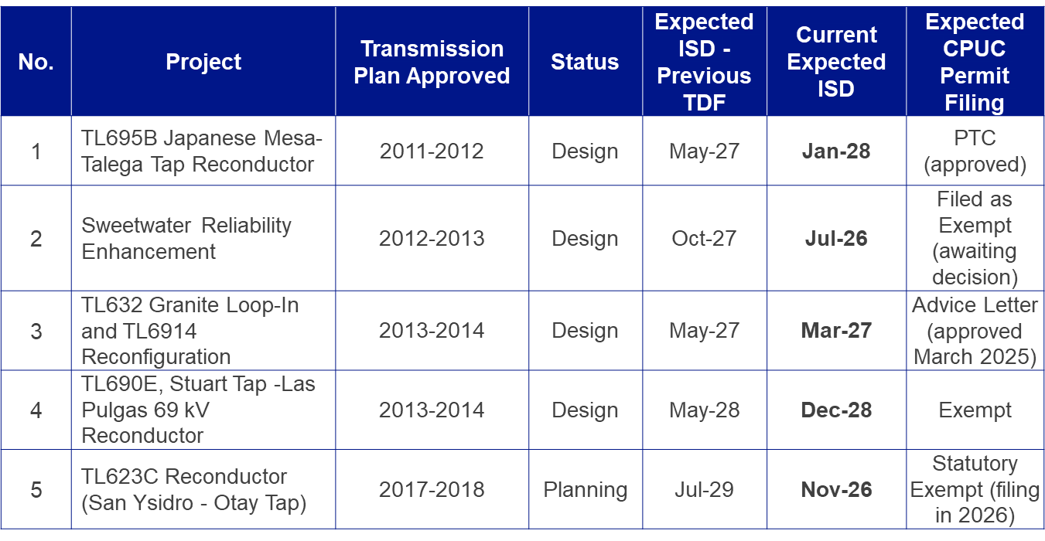  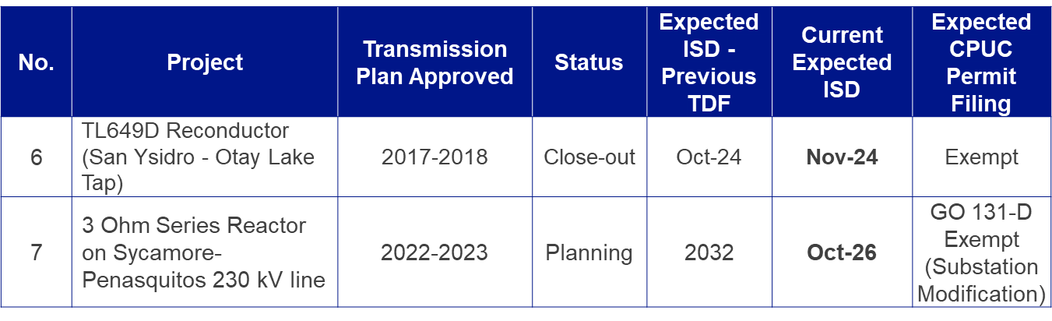  VEA/GLW RESPONSE:  GLW’s current projects do not have a CPUC permitting nexus as they are fully within Nevada, so this does not apply nor warrant a response. However, HWT is applicable and we offer the response below.  HWT RESPONSE:  HWT welcomes the opportunity for continued transparency on its CPUC permitting status, though HWT has yet to file for a permit for the projects it was selected for from the 2022-2023 TPP. HWT is already meeting quarterly with the CPUC Energy Division and will continue to work proactively with the CPUC in the prefiling process.

