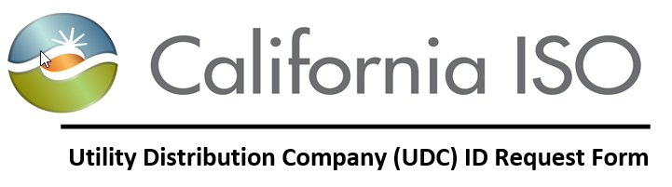
Document Owner: Model and Contract Implementation

REVISION HISTORY
VERSION NO. | DATE | REVISED BY | DESCRIPTION
1.0 | 06/04/15 | Monica | Created Document
2.0 | 07/17/18 | Pia | Updated Document Owner

Table of Contents

Purpose 3
Background 3
Instructions 3
Notification of UDC ID 4
UDC ID Request Form 4

Purpose
Provide instructions to the UDC on how to complete and submit a UDC ID request form.

Background

This process was created to identify the steps required to establish a new UDC ID. To request for a new UDC ID, the UDC will need to submit a completed form to pdr@caiso.com.

Instructions

There are two sections on the UDC ID request form (Section 1 & 2).

Section 1: (To be completed by the UDC)

The UDC will need to complete the following fields:
- Submission Date
- Organization Name
- Point of Contact (include name, phone, and email)

Once these fields have been updated, please save the document and email it to pdr@caiso.com for review and approval.

Section 2: (To be completed by the PDR Coordinator)

The PDR Coordinator will create an UDC ID, determine a UDC ID effective date, and approve the request.

Notification of UDC ID

The PDR Coordinator shall notify the UDC ID Requestor via email with the following information:
- Approval/Rejection
- If approved, the new UDC ID and Master File effective date.

UDC ID Request Form

Section 1: To be completed the UDC Point of Contact:

REQUESTOR INFORMATION
Submission Date
Organization Name
Point of Contact
(Name, Phone, Email)

Section 2: To be completed by CAISO PDR Coordinator:

NEW UDC ID STATUS
Approved by PDR Coordinator (Y/N)
New UDC ID
Proposed MF Effective Date

Please submit the completed request form to PDR@caiso.com and allow ten (10) business days to process the request.

